## **Lab #4: DNS Tricks with Kali**

### **Overview**

This lab will show you how Linux computers are able to look up a website before you access it online, and how it can be used to send you to a different spot on the web!

### **🎯 Goals**

By the end of this lab you will be able to...

* Learn about the Kali Linux folder structure and commands to navigate in the terminal
* Examine the hosts file in Linux and its role in looking up a resource
* Learn how spoofing works to redirect to a fake website

In order to accomplish this, you will...

* Show in the console that the website is pointing to a different IP address
* Show that the web page is showing a different site

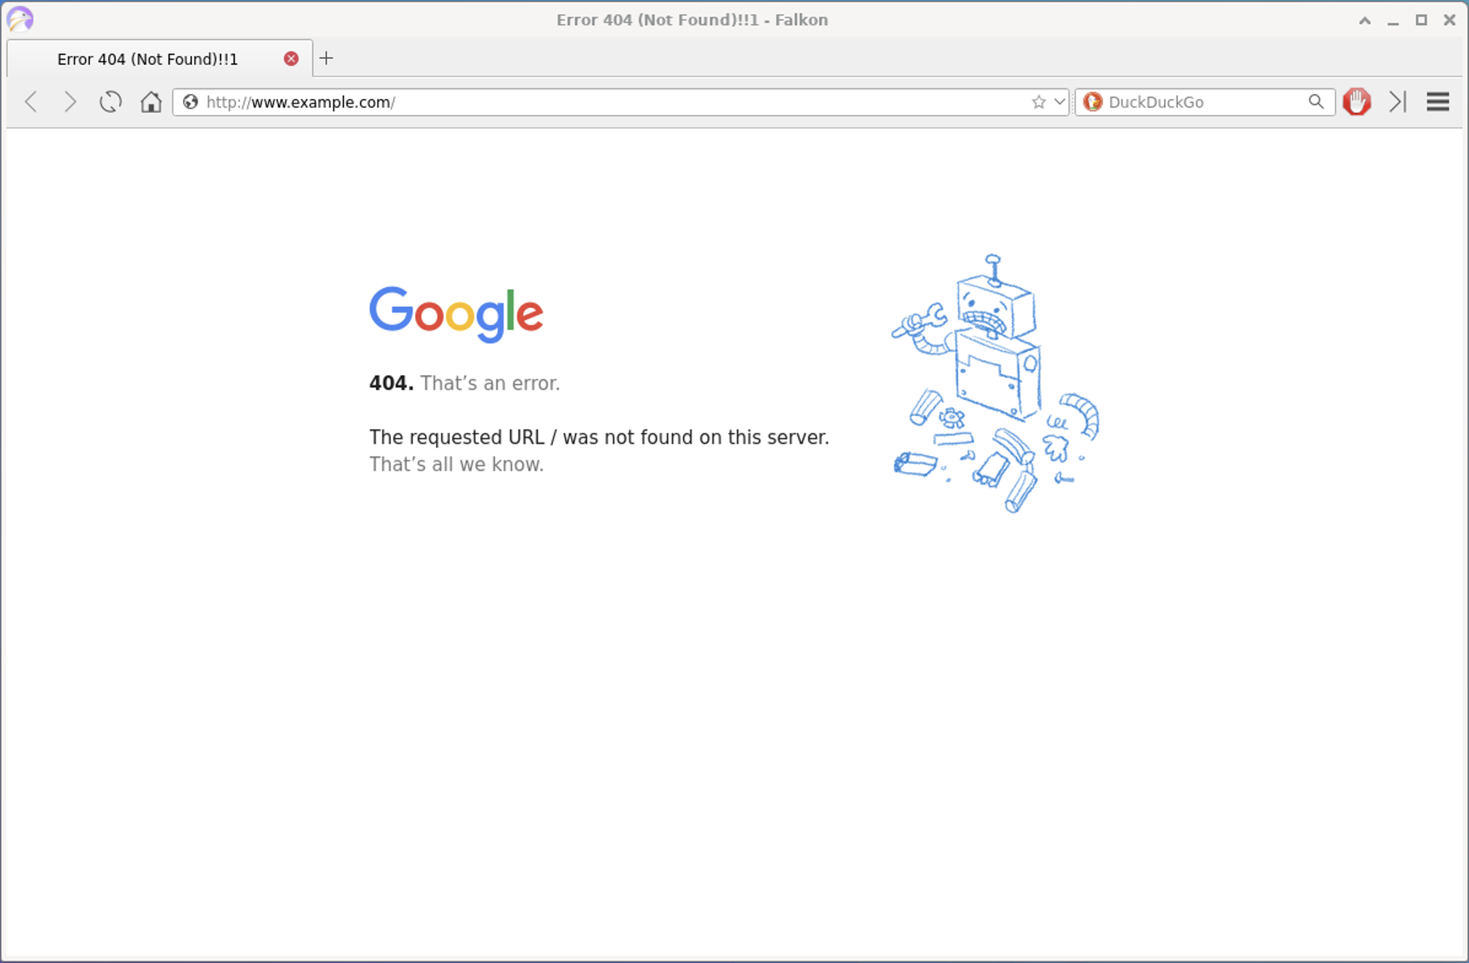

### **Resources**

* [How to Clear the DNS Cache in Windows](https://www.siteground.com/kb/clear-dns-cache-in-windows/)
  + The first two sections have good information about how the DNS Cache works and why it's important to clear it (this applies to Linux systems too)

## **Lab Instructions**

### **Required Features**

#### **Step 0: Check the IP Addresses for Different Two Websites**

* Open up an RDP connection to Kali.
* In your Kali machine, open a terminal prompt. You can do so by navigating to Applications -> Terminal Emulator.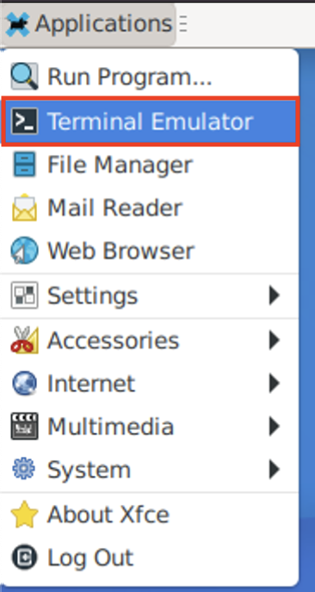
* We will first be using the [ping command](https://www.redhat.com/sysadmin/ping-traceroute-netstat), which we will use to send out a message (in the form of a packet of information) to Google's servers. If the server is available, it will send a reply back to us. If it's not, we'll see that show as well as a response in the terminal output.
* Type ping www.google.com in the terminal. Once you hit enter, you'll see the pings start. Let it continue until you've captured about four (4) pings, and then type Control + C in order to stop the command.
* Let's analyze this information! In parenthesis, you'll see the website's [IP address](https://www.avast.com/c-what-is-an-ip-address). The IP address is the unique number that has been assigned to the website (usually by an [Internet Service Provider](https://www.investopedia.com/terms/i/isp.asp)) and identifies it on the internet. Note the IP address that is reflected for www.google.com in the pings:

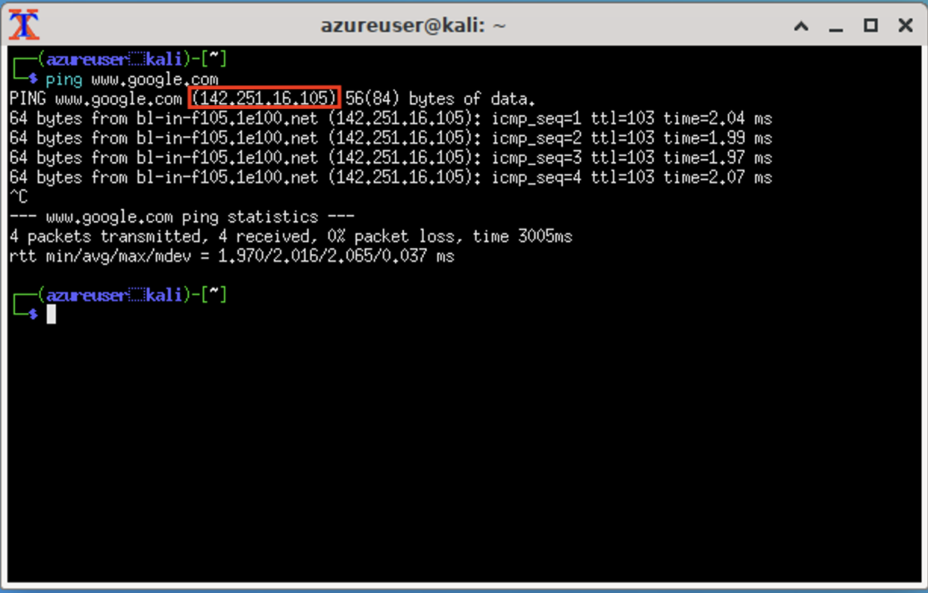

* Next, in the same terminal, type ping www.example.com. Note the IP address that is reflected for www.example.com in the pings:

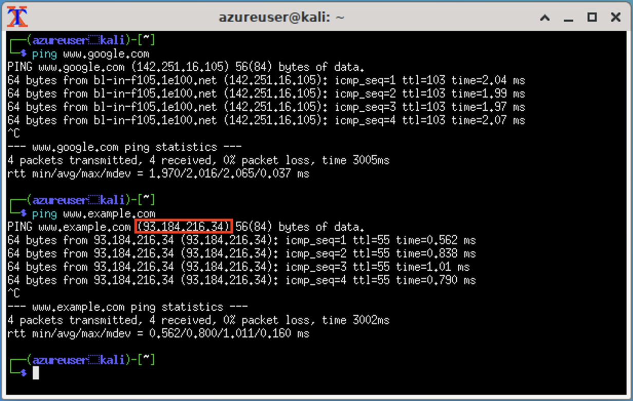

Other pieces to note here in the console is that you'll see the size of the data packets that have been sent for each request (in this case, 64 bytes), as well as the time it took for the response to come back for each one (measured in milliseconds).

At the bottom of each ping for the web address you'll see a summary of this information (statistics) printed out for you in the console.

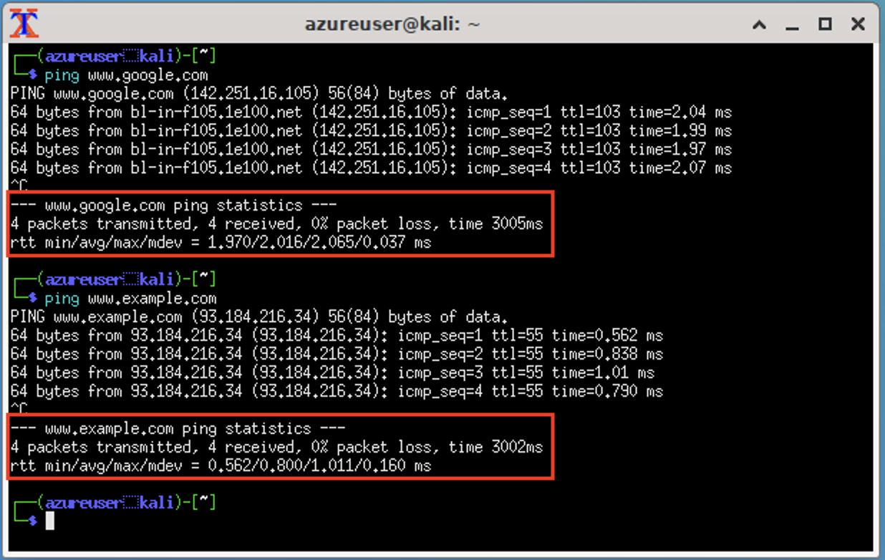

🎯 **Checkpoint 0**: Great! You have used the **ping** command to check and test the network connectivity and verified the IP addresses to two different sites.

#### **Step 1: Install Falkon Browser**

* You may already have [Falkon browser](https://www.falkon.org/download/) installed on your Kali Linux box from the Unit 2 lab Kali machine setup. In case you don't have it already, please install with the following command:

sudo apt install -y falkon

* You can check to see if it is installed by going to the top left menu under Applications -> Internet -> Falkon (as shown below):  
  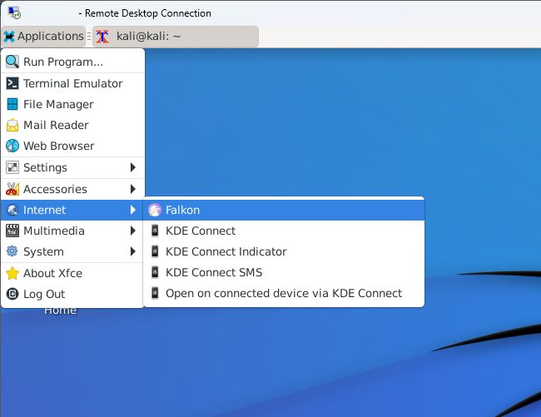

🎯 **Checkpoint 1**: If you have a browser installed, you're ready to go with the next sections!

#### **Step 2: Navigate to Hosts File**

Now, we will take a look at the hosts file.

* In the RDP connection in your Kali machine, open up another terminal prompt using the same steps as you did for the first one (Applications -> Terminal Emulator). In the top bar of your Kali window, you should now see that there are two prompts open in the menu, and you'll be able to switch back and forth between these two windows.

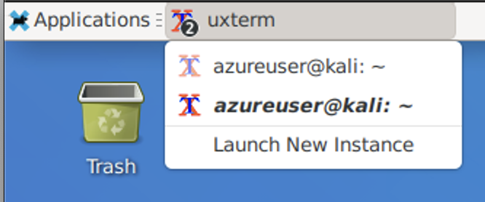

* In the new open terminal window, type pwd. This command is short for print working directory, which will let you know the full path of the directory you are currently in. You should see /home/azureuser as listed below:

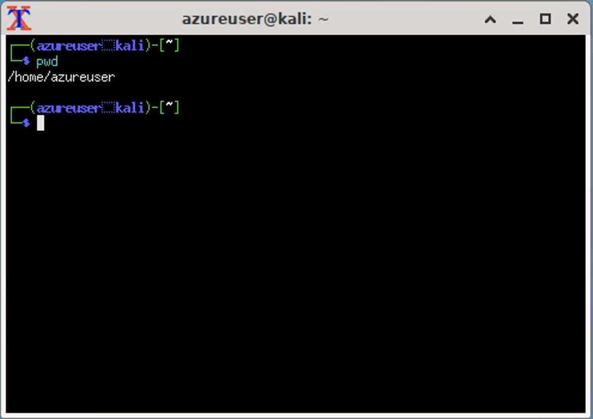

* From here, you can type ls to see the files that are in this directory. ls is short for list.

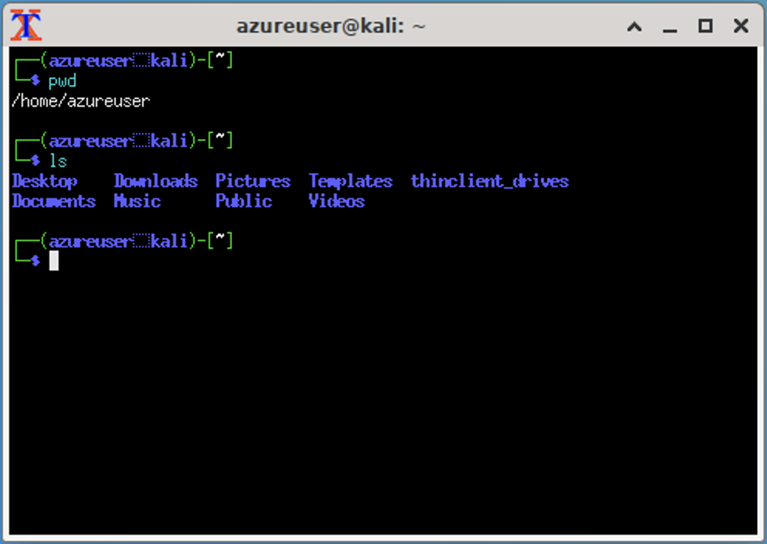

* We can see all of the folders show up in the blue colors. Let's navigate into the Documents folder by typing cd Documents:

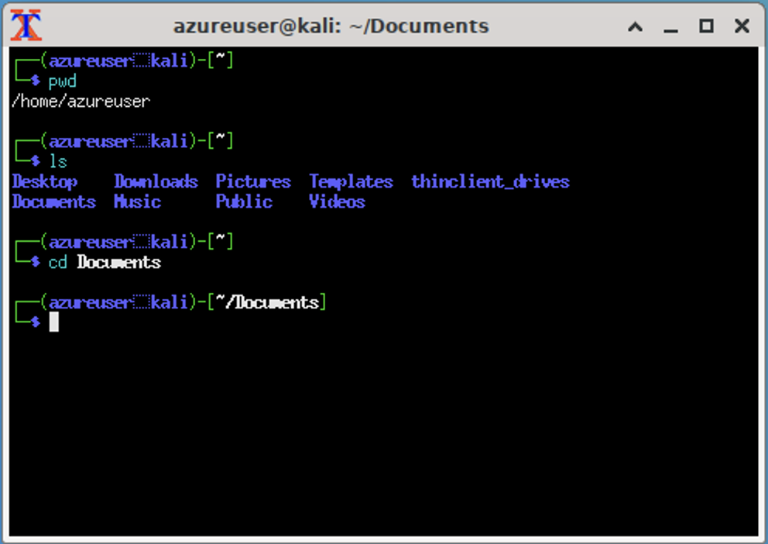

* Type pwd again. This should now list the path as /home/azureuser/Documents:

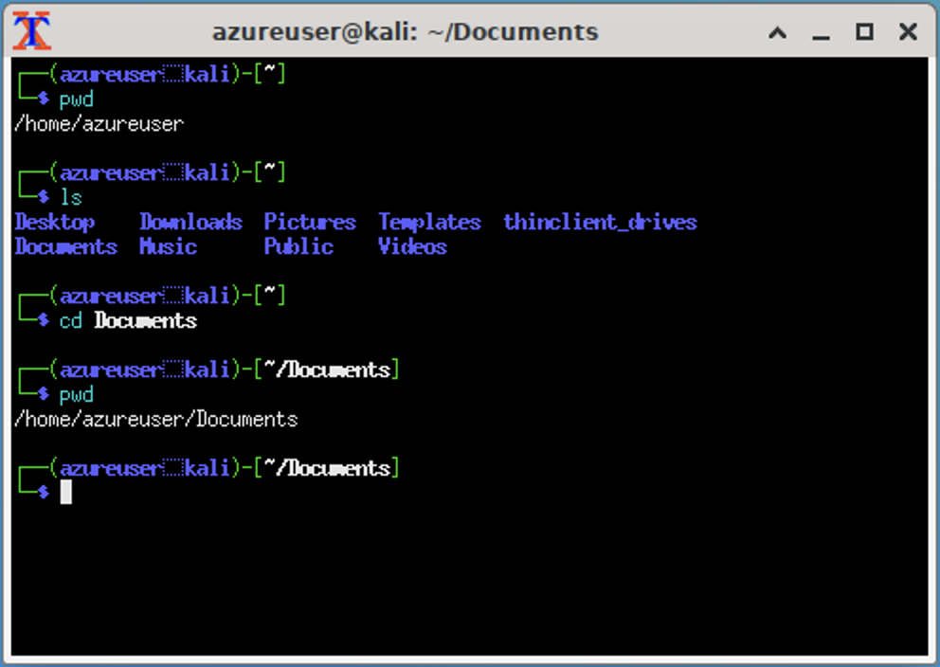

* Type ls to list the files in the Documents directory. For this Kali machine, there are no files here, yet if you may have some that you've saved in this location, and you'll see them listed here.

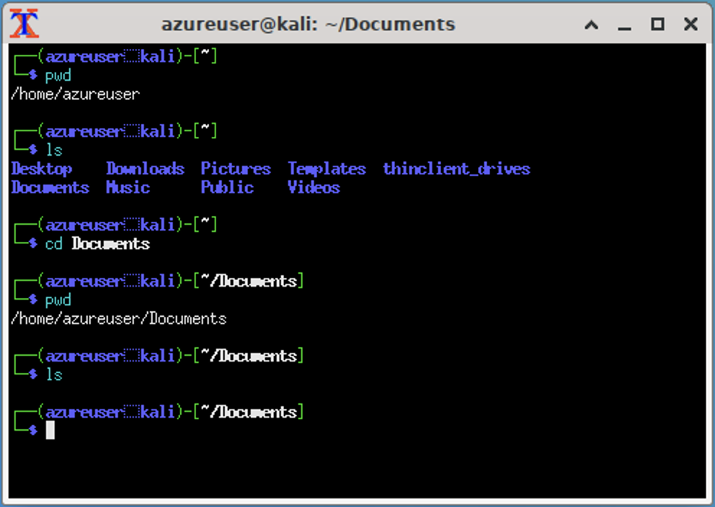

* In the new open terminal window, type cd ~. This command will always take you to your home directory in case you might be in a different place in the file system.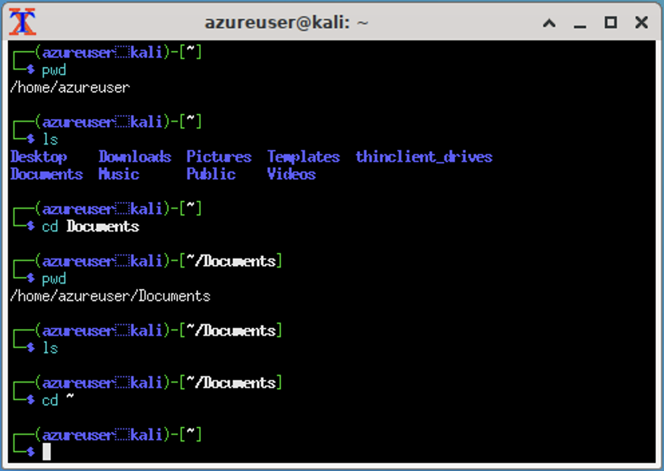
* Type pwd. This should now list /home/azureuser (your home directory).

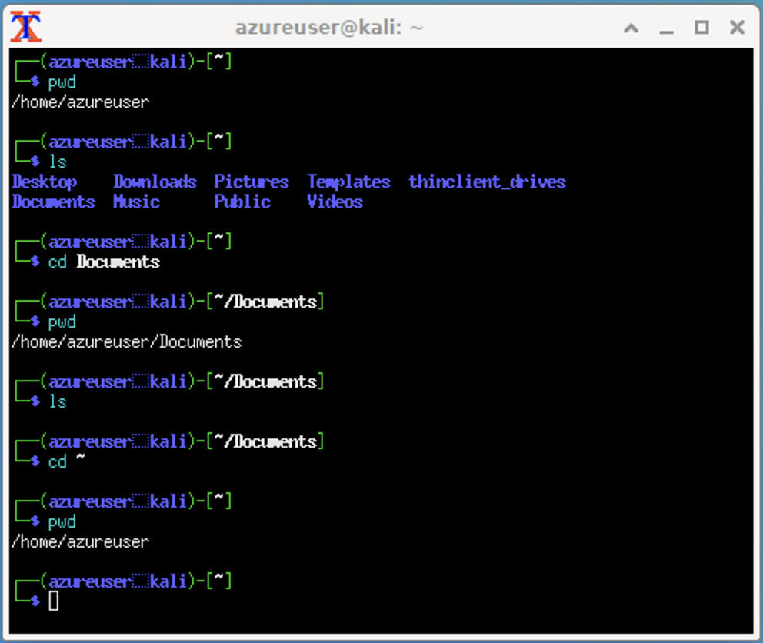

* Type cd .. to go up one directory. This is called the **parent** directory to the one we were just in.

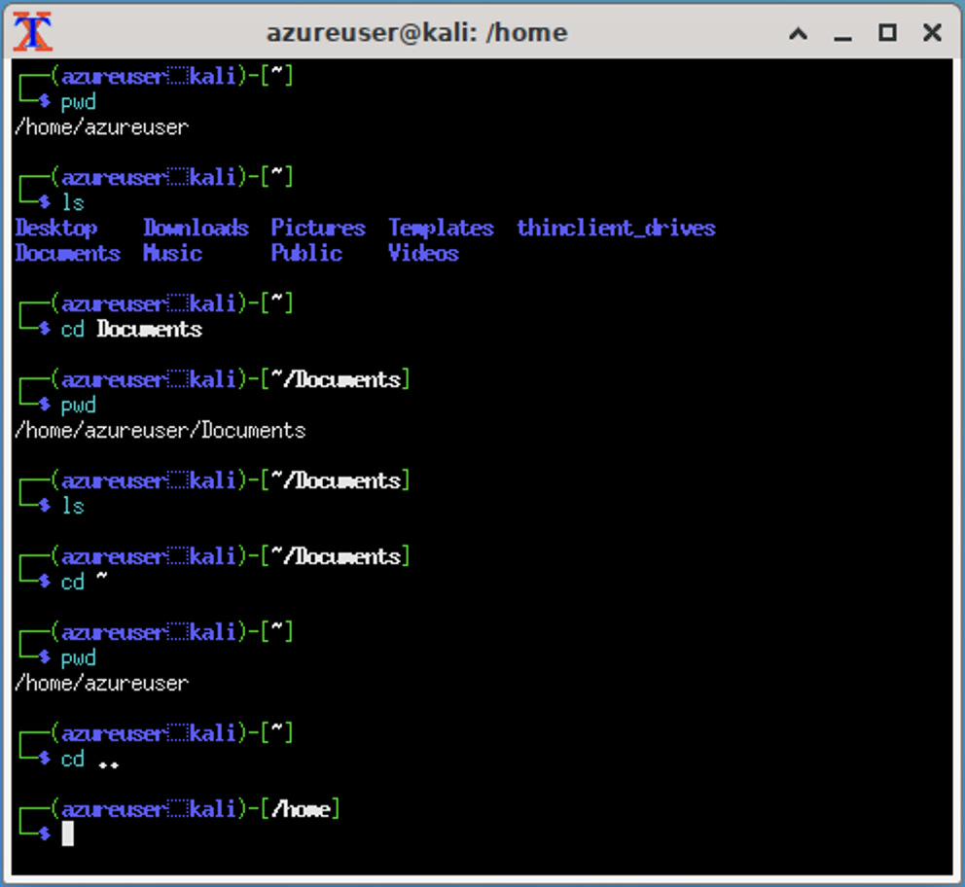

* Type pwd. We can confirm that we are in the /home folder now. Notice how the terminal prompt also matches and prints this out as well.

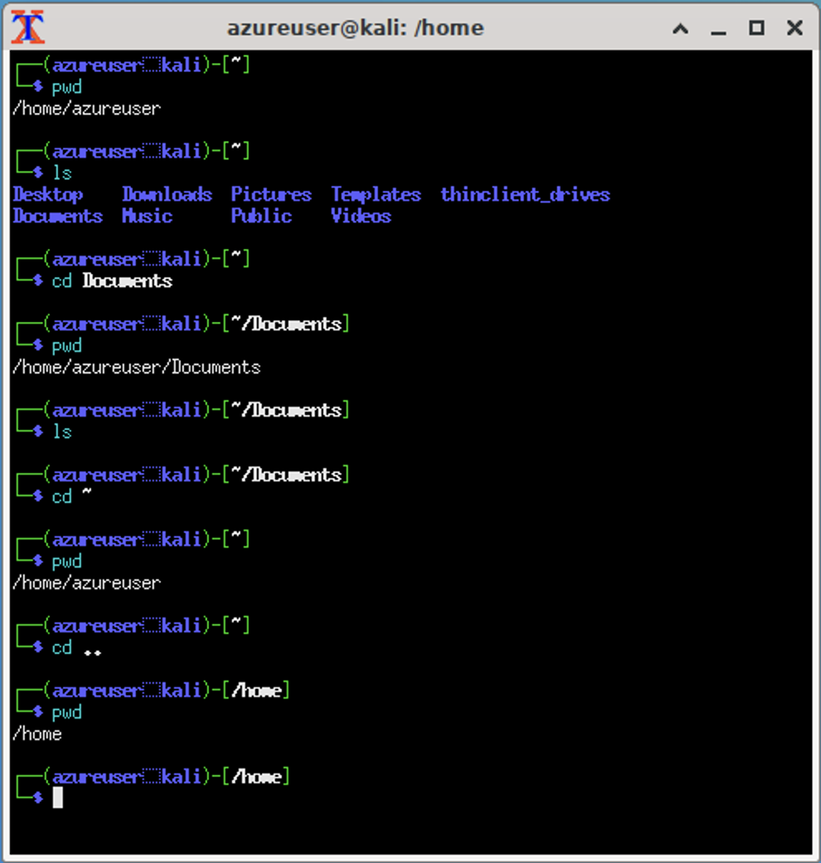

* Type ls. Here we see our azureuser.

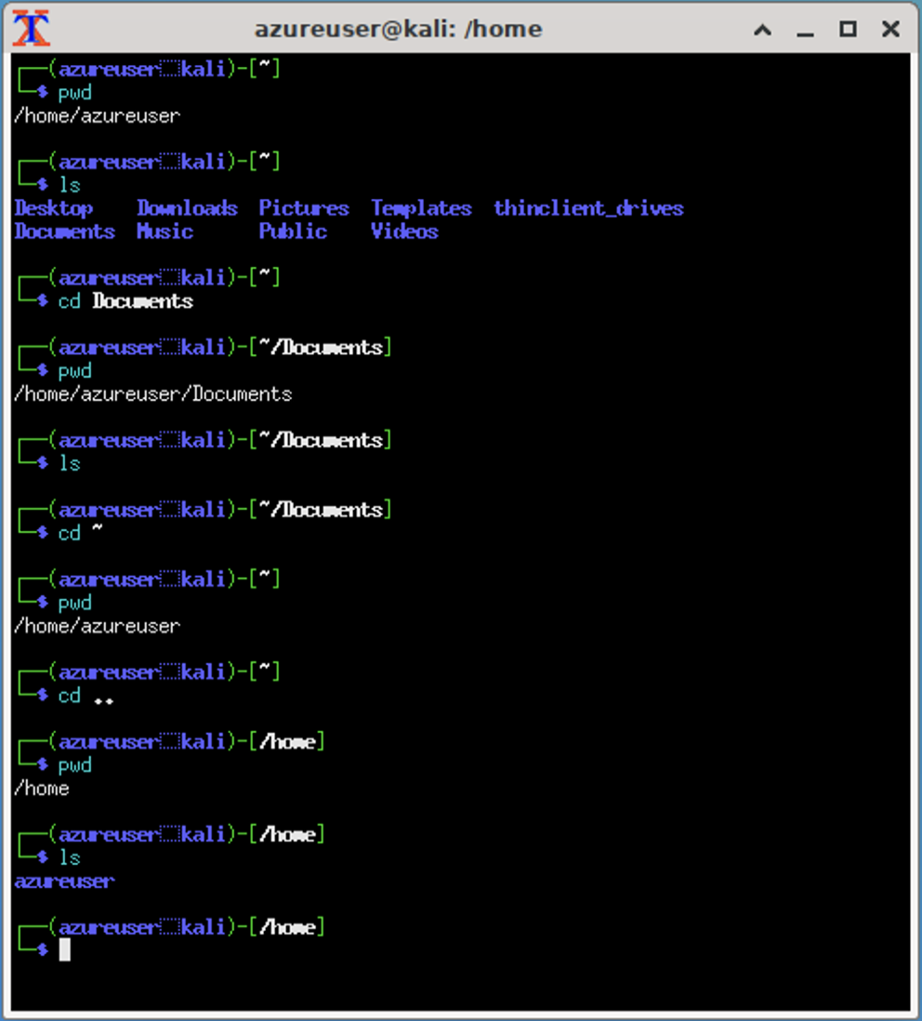

* Type cd .. to go up one more directory.

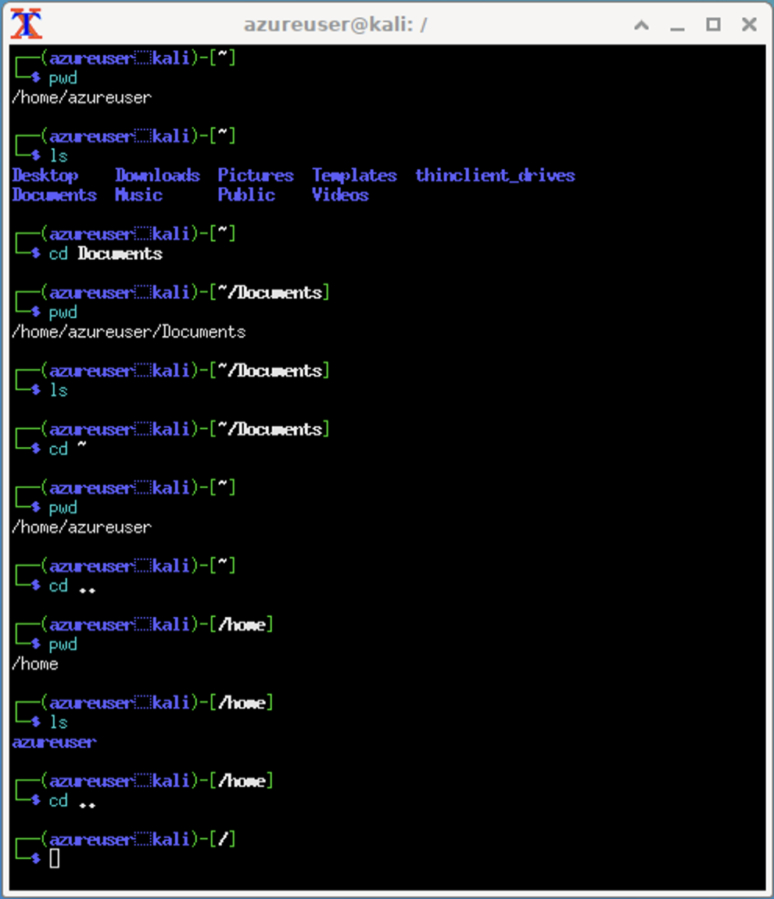

* Type pwd. We can confirm that we are in the /home folder now. Notice how the terminal prompt also matches and prints this out as well.

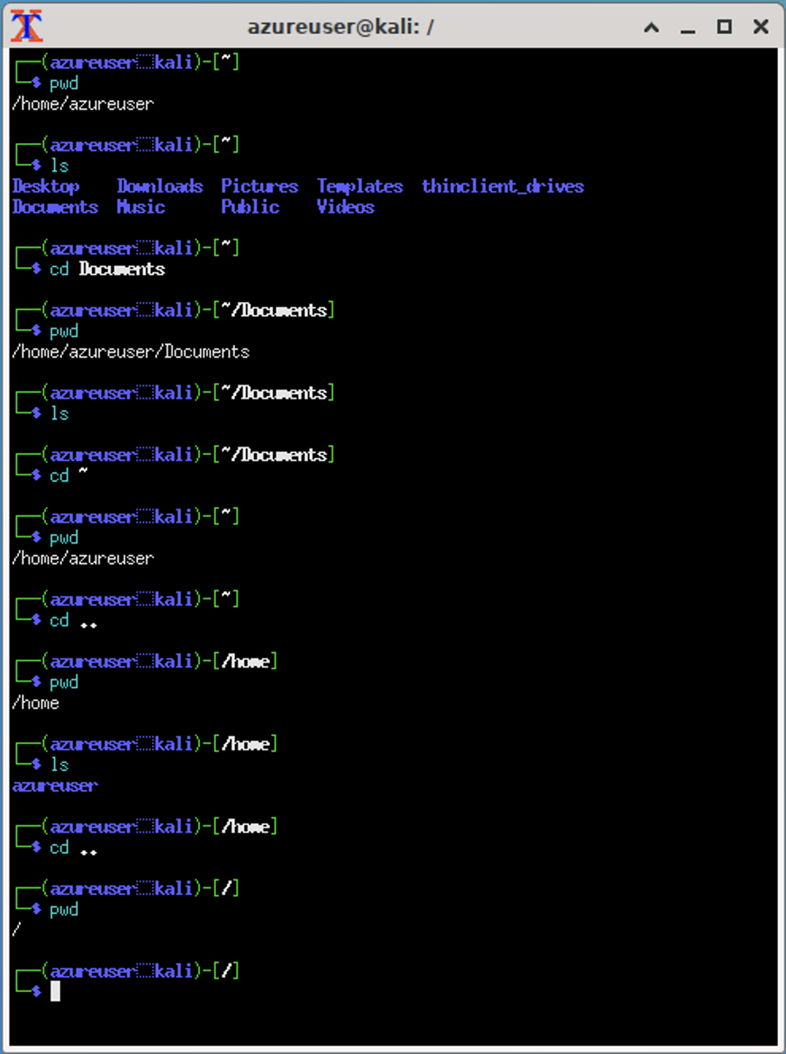

* Type ls. Here we are able to see the /etc folder in the list.

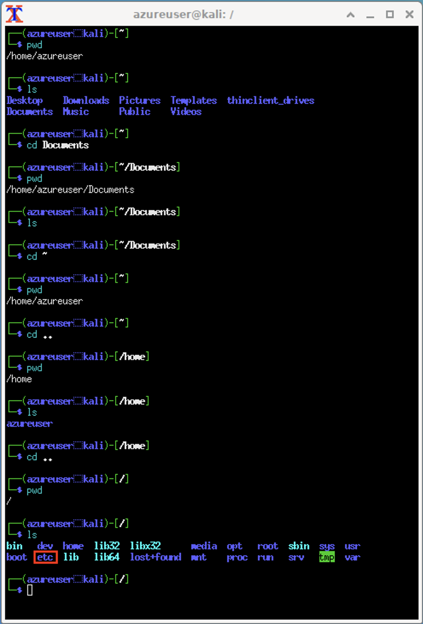

* We will navigate to the etc folder from here -- change directory into the etc folder.

cd etc

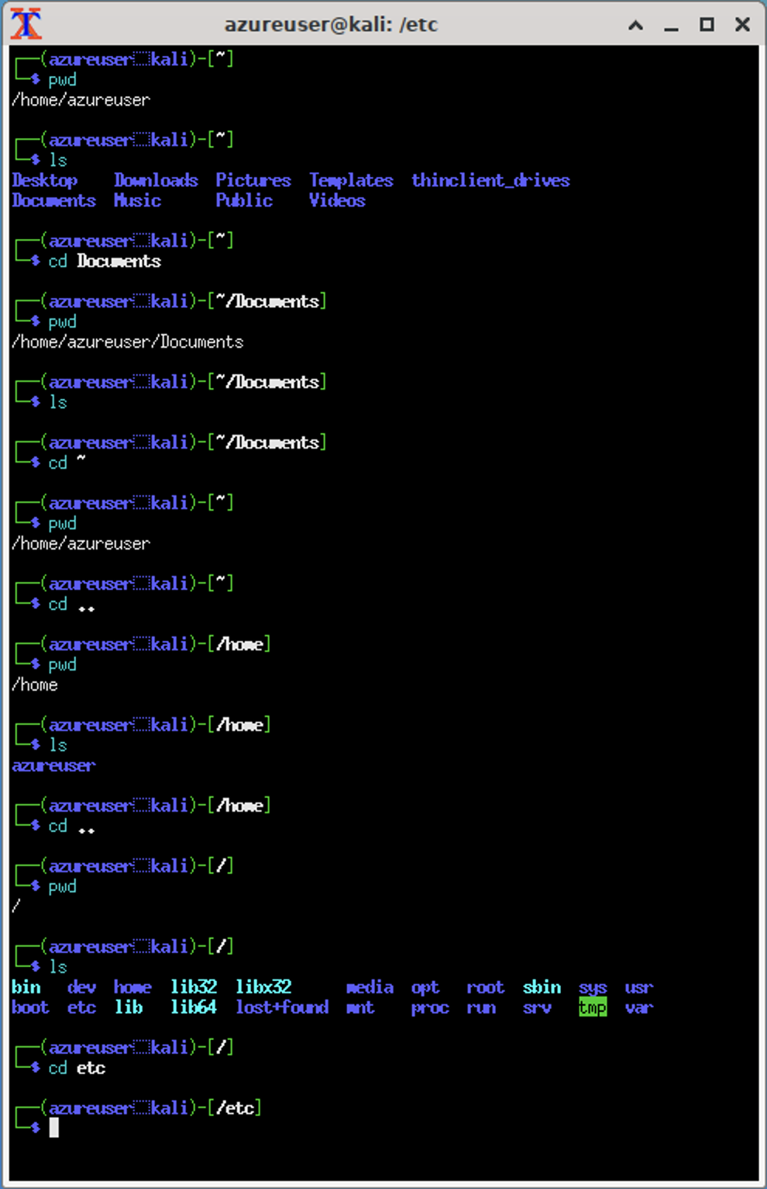

* Type pwd. Here you will be able to confirm that you navigated into the /etc folder.

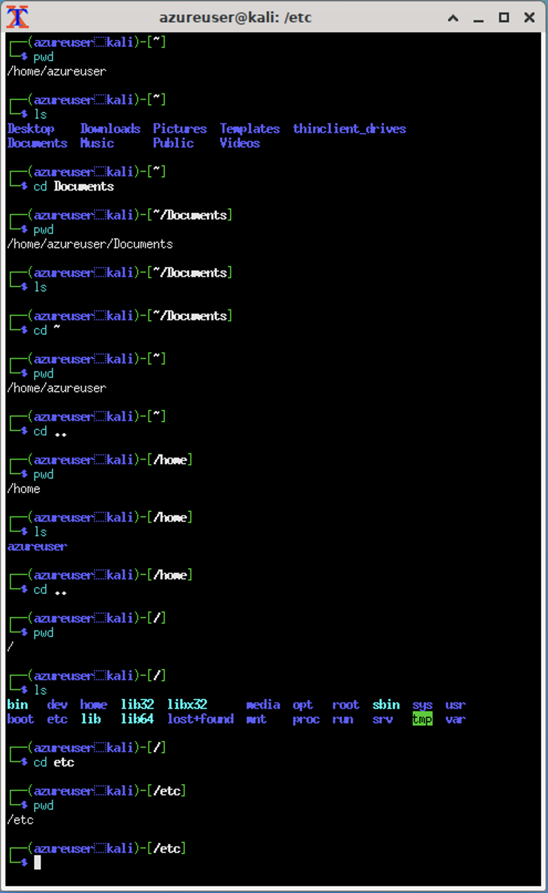

* If we type ls, we will see all the contained files. Here we will find the hosts file in the list.

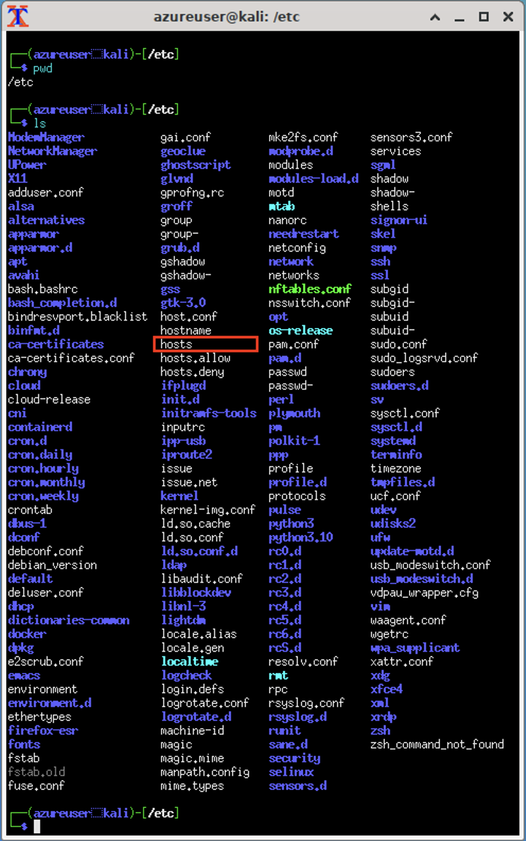

🎯 **Checkpoint 2**: You've been able to try out a few different commands in the terminal:

1. cd ~ to go to the home directory,
2. pwd to print the working directory,
3. ls to list the contents of the current directory,
4. cd <folder> to navigate into a directory,
5. cd .. to go up one directory (**parent** directory), and
6. nano to open up a file in a text editor.

These commands will be ones that you will use often when working in the command line. Feel free to refer to this section whenever you need a refresher! 

#### **Step 3: Examine the Hosts file**

* Let's take a look at this file! In order to open it, we can use nano text editor. Type:

nano hosts

* Press enter. Here you will see the file open up, and it will look something similar to this.

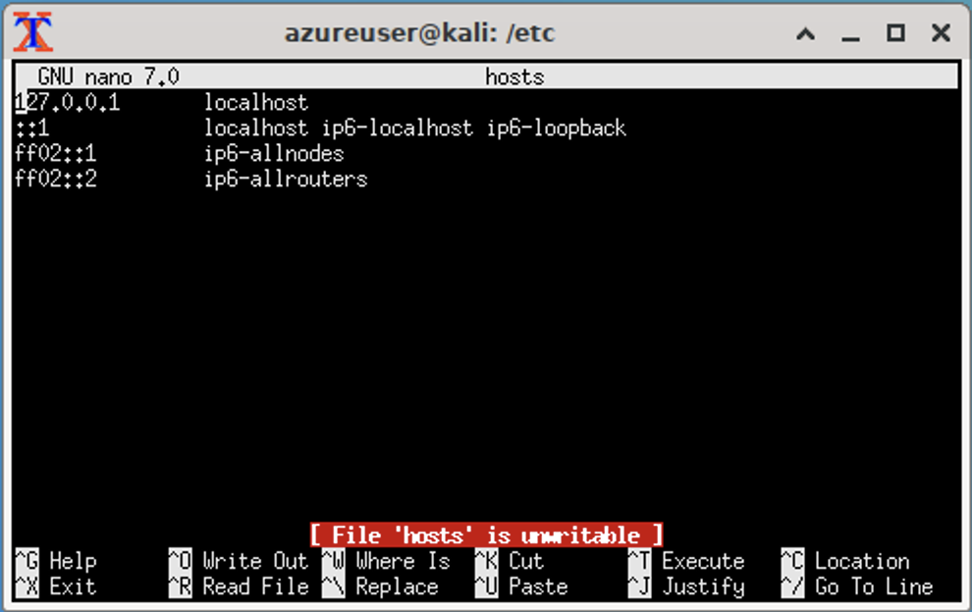

For our purposes, all we need to know is that these four (4) lines and settings are all needed in the hosts file as default so that communication can happen to translate the host names we search for into an IP address. The first one is our localhost, and is the way that the Kali machine knows how to talk to itself. If you're curious and would like to read more about what each of these different addresses mean, please take a look at this [Understanding Ubuntu's Hosts File](https://www.linuxfordevices.com/tutorials/linux/understanding-ubuntus-hosts-file) article, which also applies to our Kali linux hosts file.

You may also see a message in the terminal window that says File 'hosts' is unwritable. This is because when we opened the file using nano hosts, we opened it in viewing mode, which will not allow us to make edits. We don't have to worry about this for now since we are only examining the file, yet we'll use a different command when we want to edit it later.

* Type Control-X to exit this screen and go back to the terminal prompt.

🎯 **Checkpoint 3**: You've examined the default hosts file and taken a look at the settings before we make any changes.

#### **Step 4: View the Web Pages in the Browser**

Now, we'll take a look at each of these websites in the browser. We'll want to verify it's what we're expecting to see when we go to them directly.

* Open the Falkon browser (by navigating to Applications -> Internet -> Falkon) and open a new browser window.  
  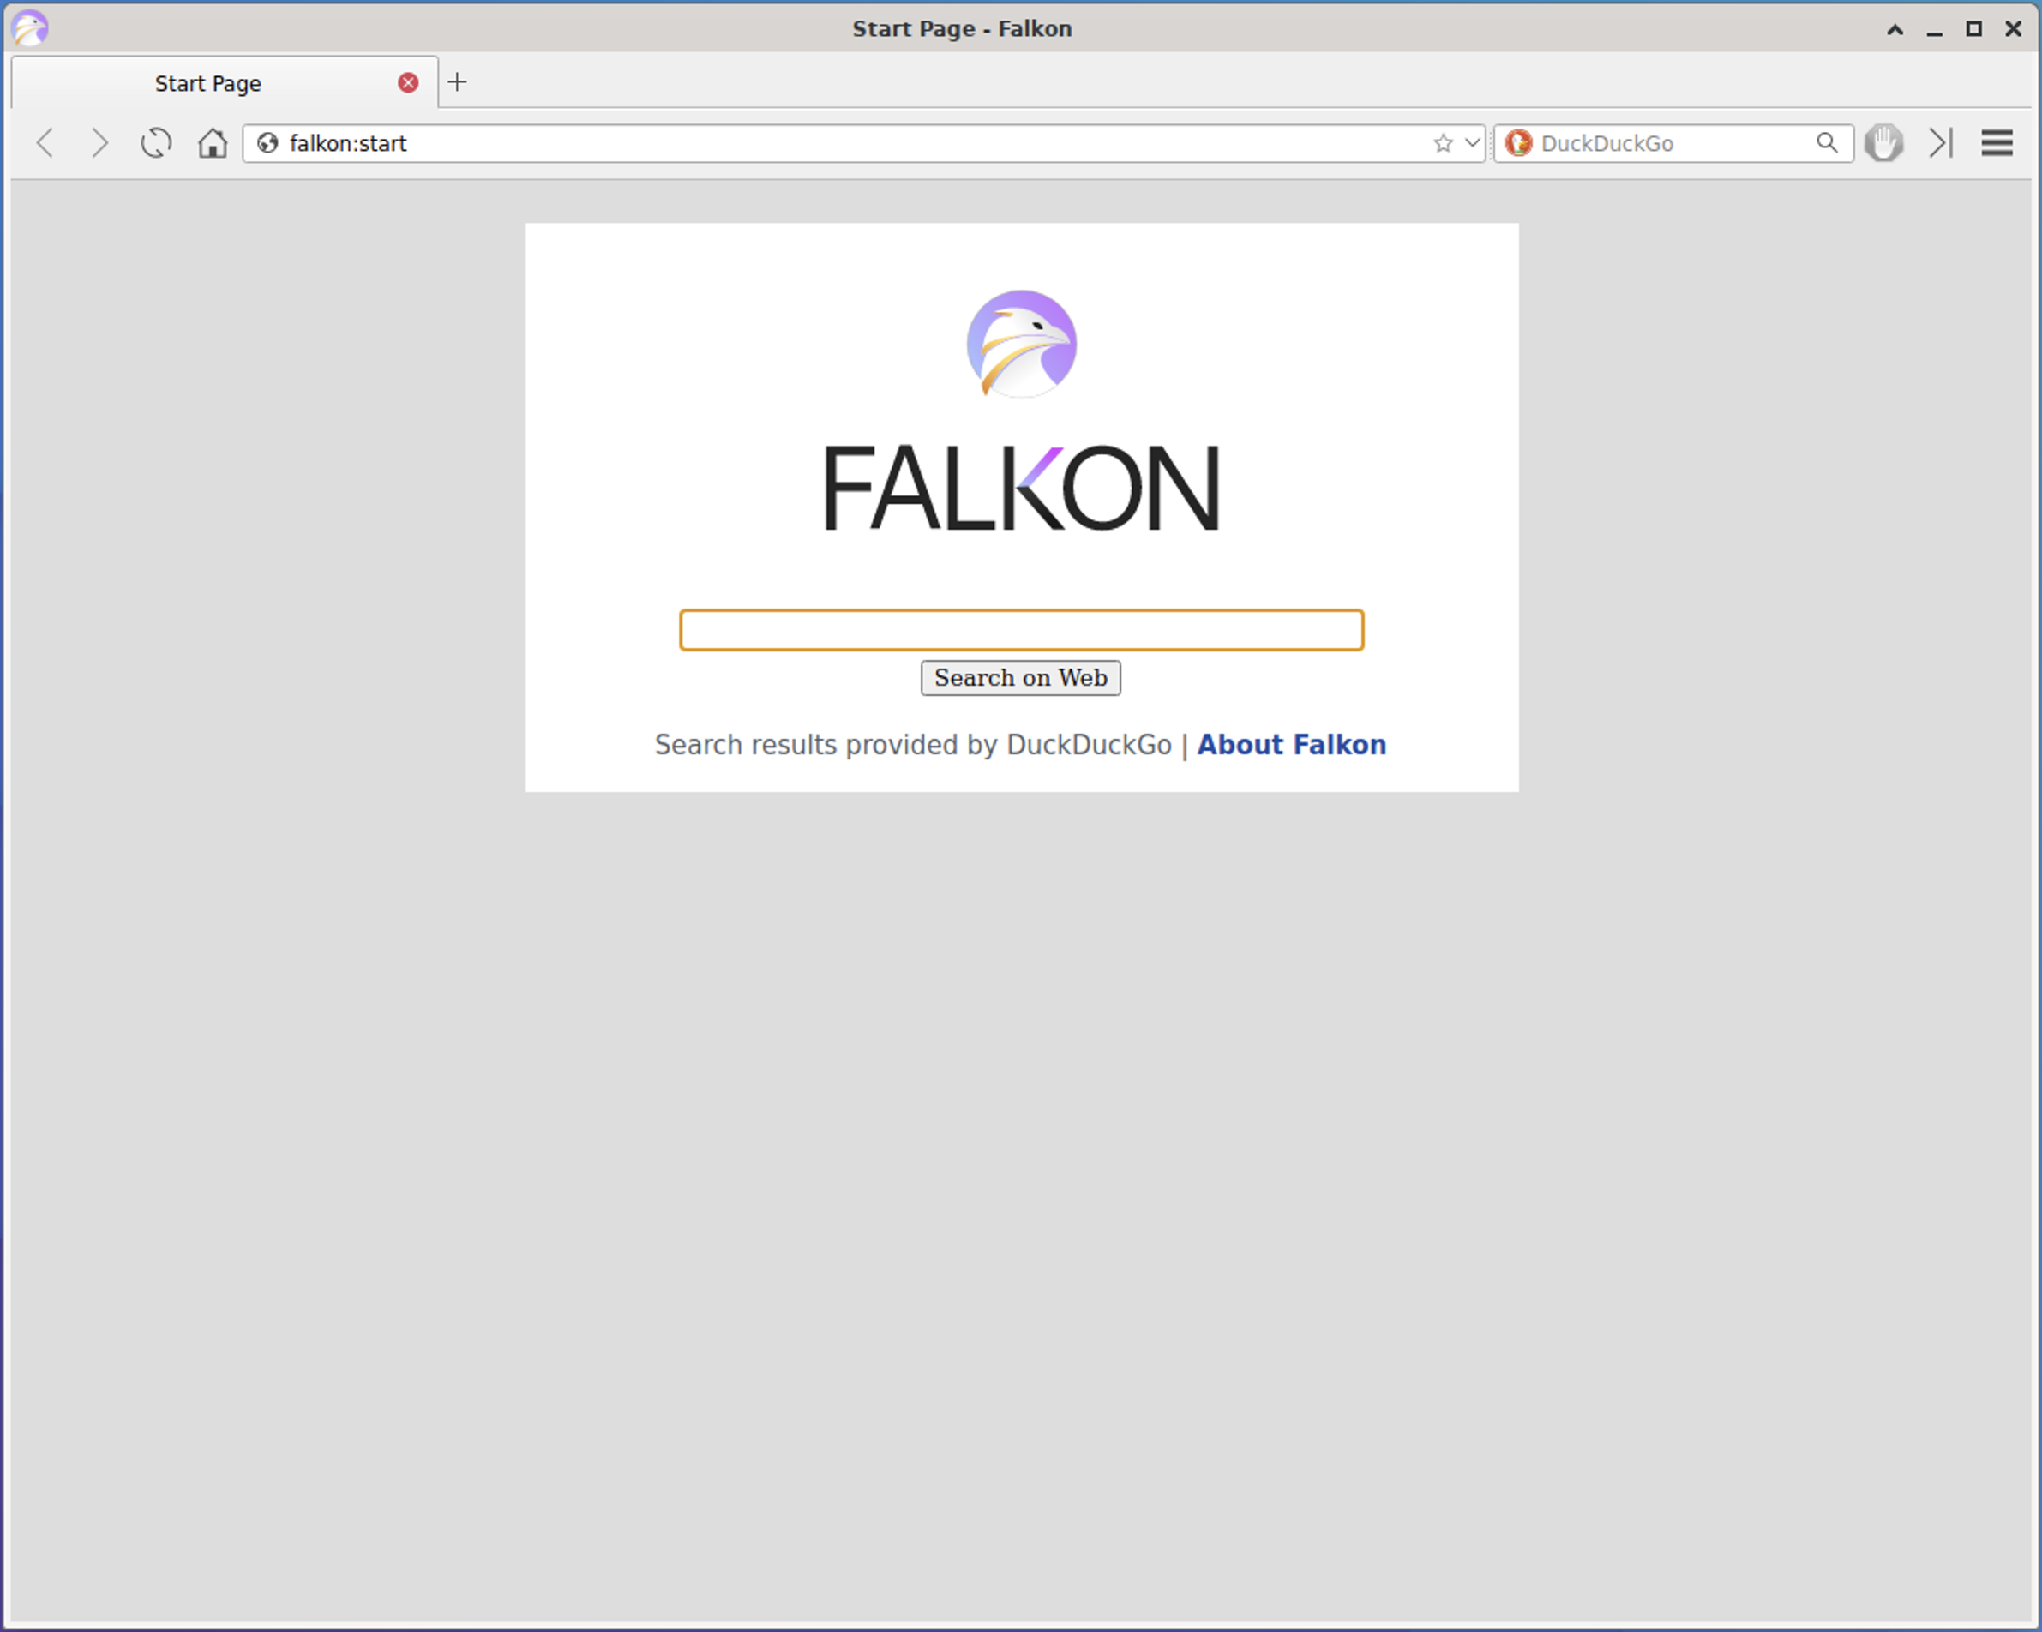
* Let's first take a look at Google's Search Engine site. In the address bar at the top, type www.google.com.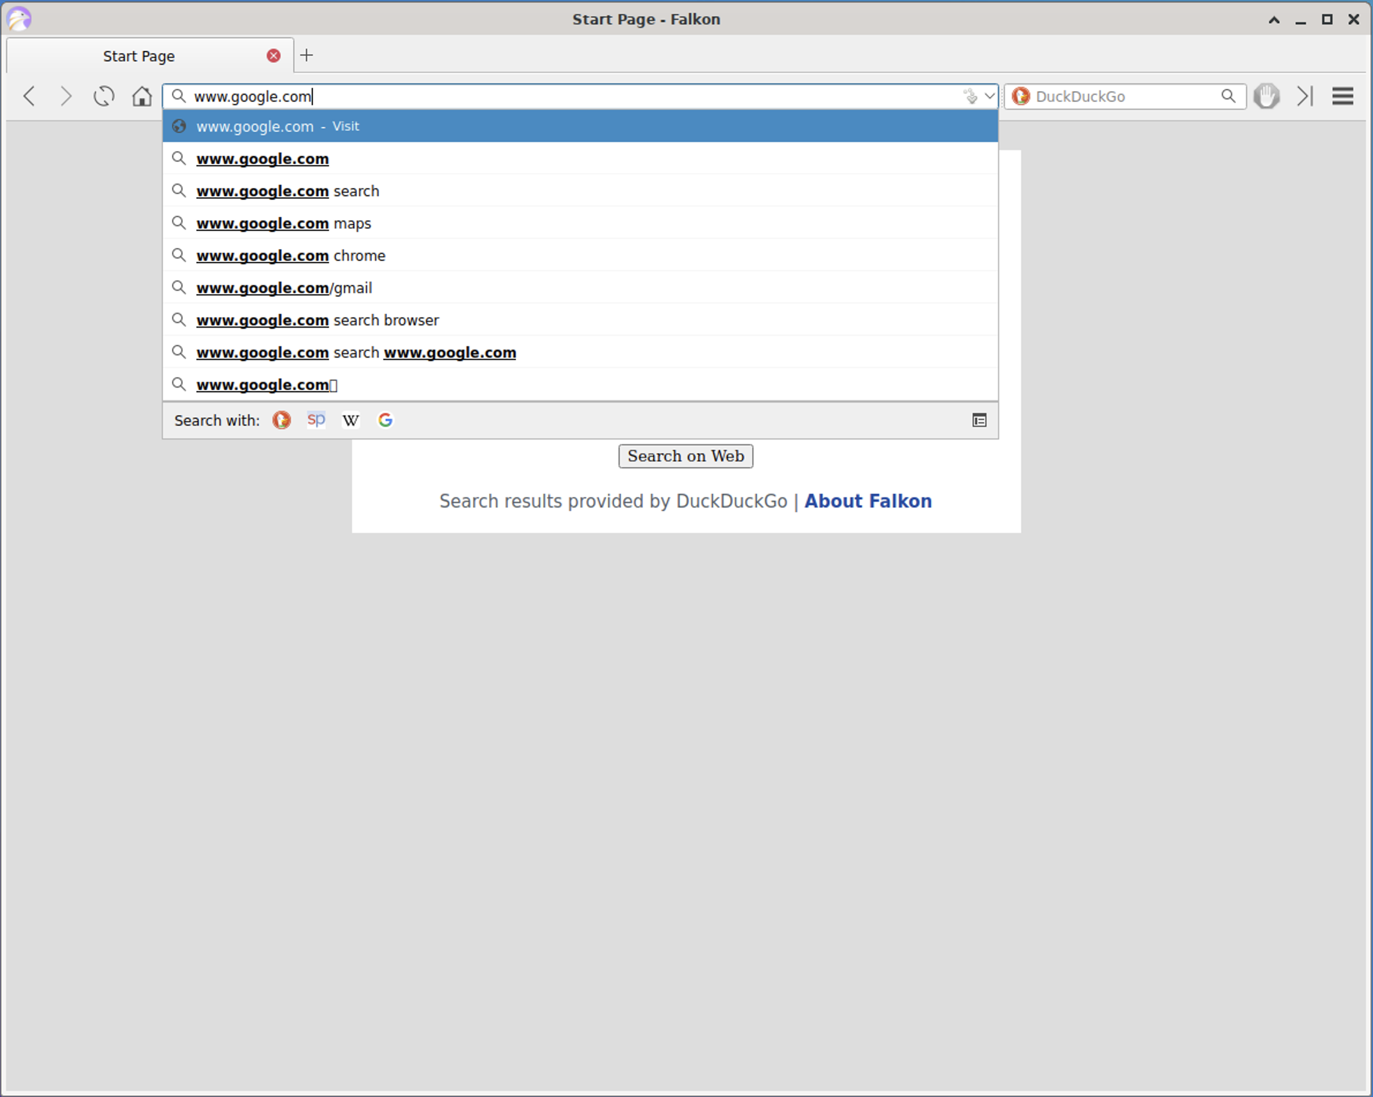
* Press enter in the address bar. It will navigate to www.google.com. In case it gives a prompt to "Sign in to Google", click on "No thanks".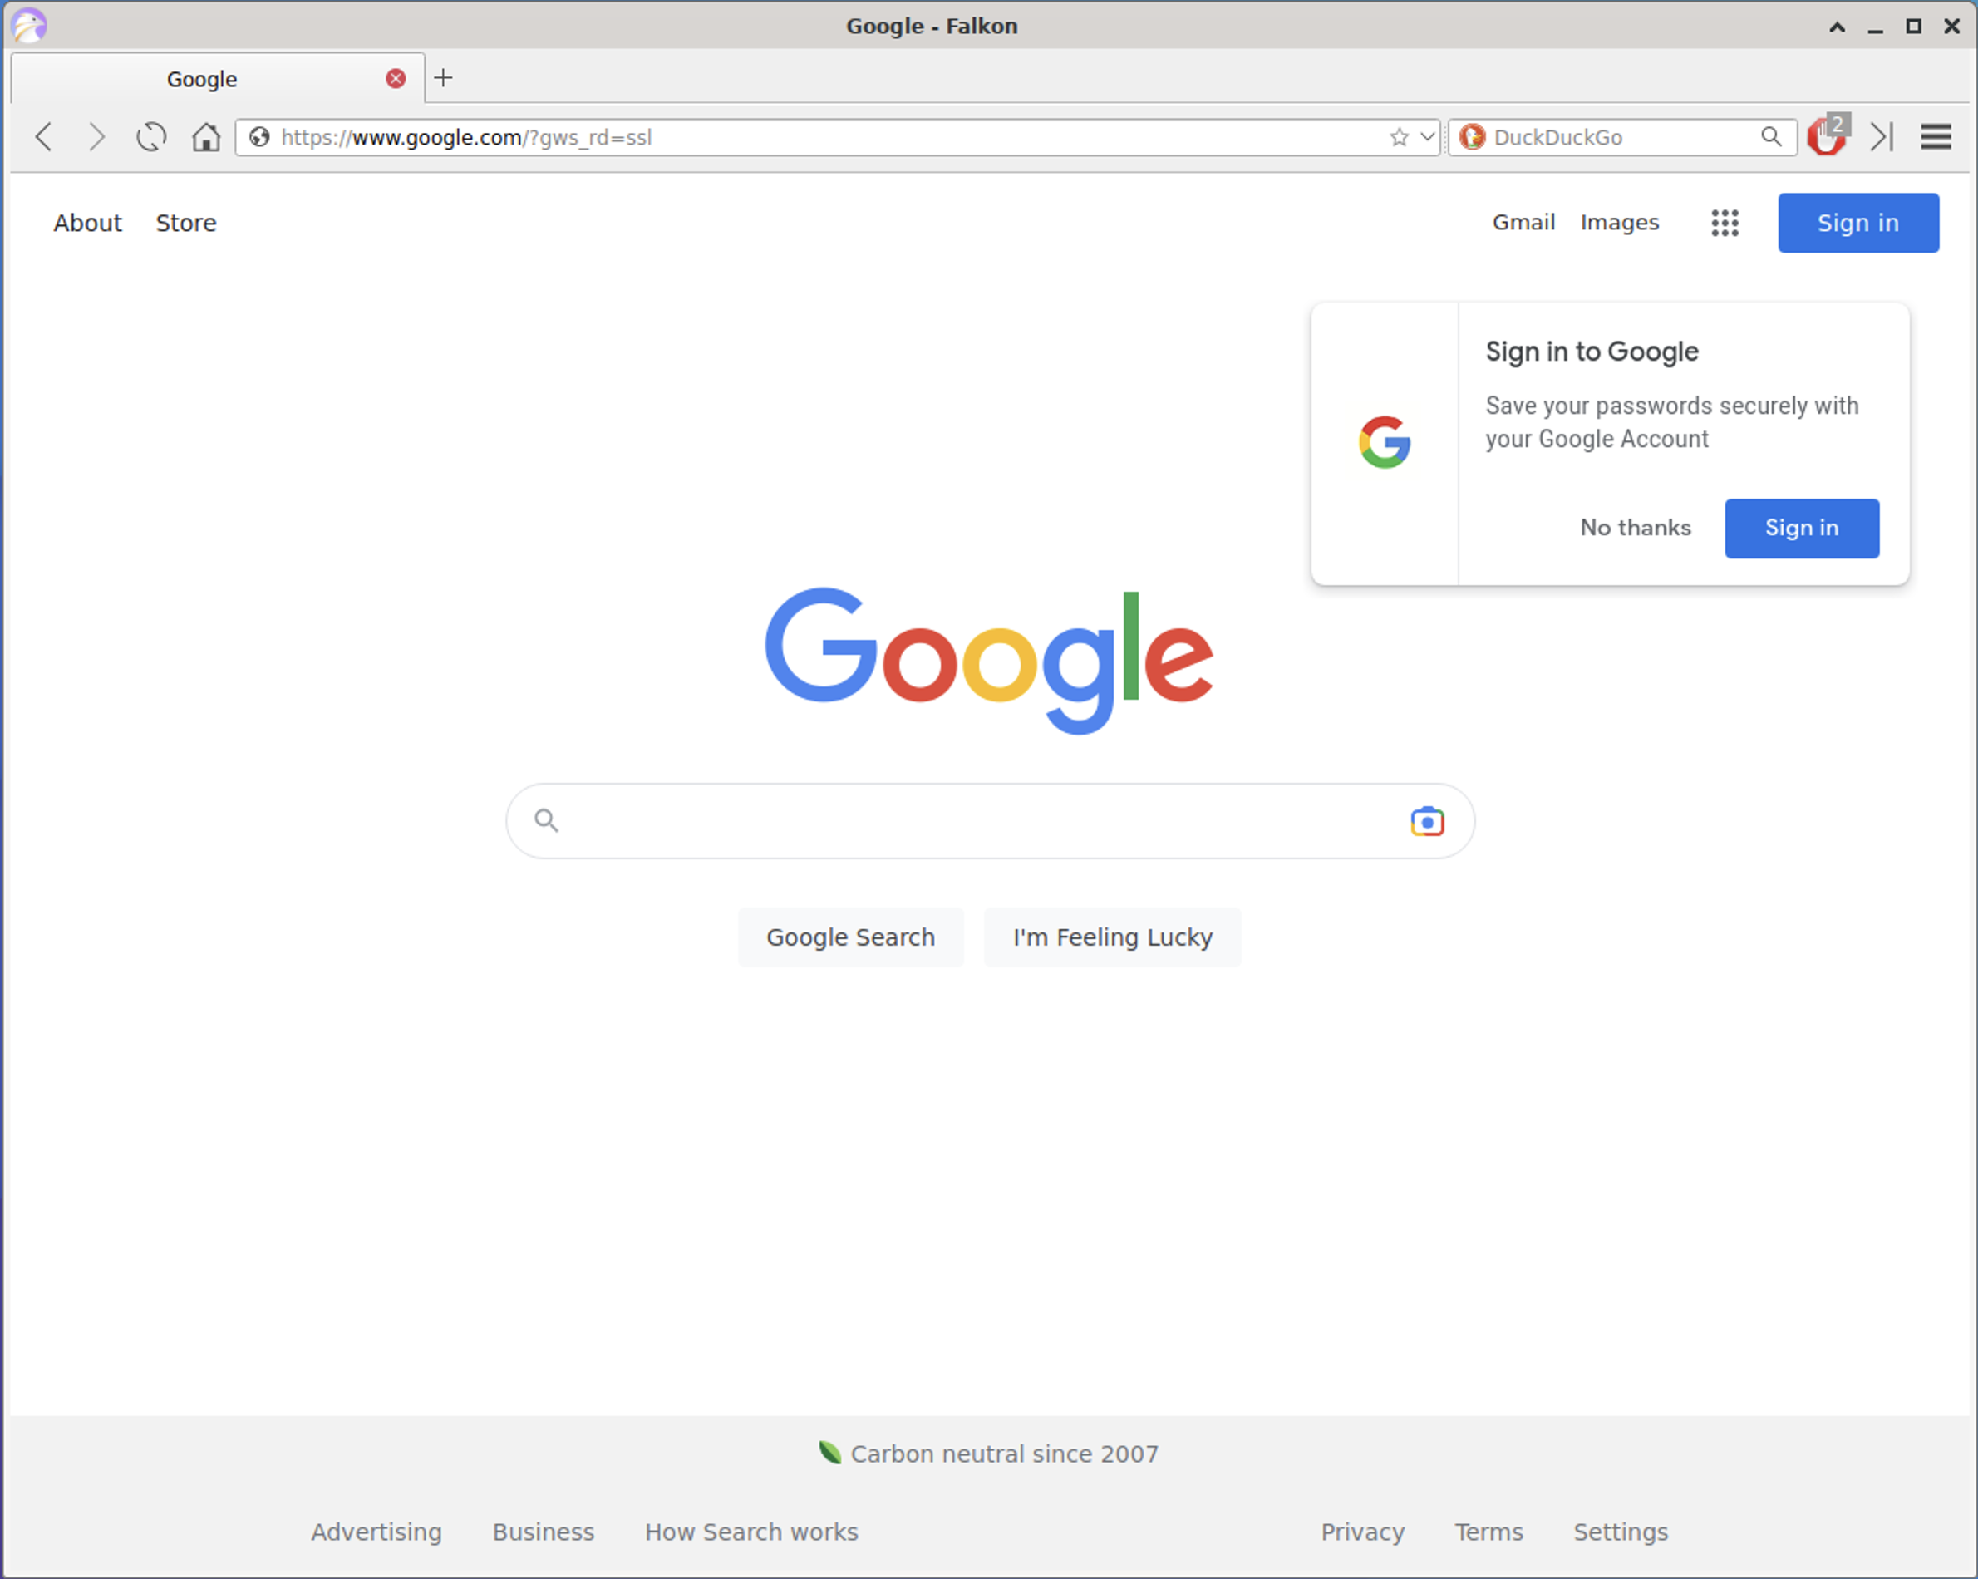
* Note the url in the address bar that is shown. In this case, it's showing https://www.google.com/?gws_rd=ssl.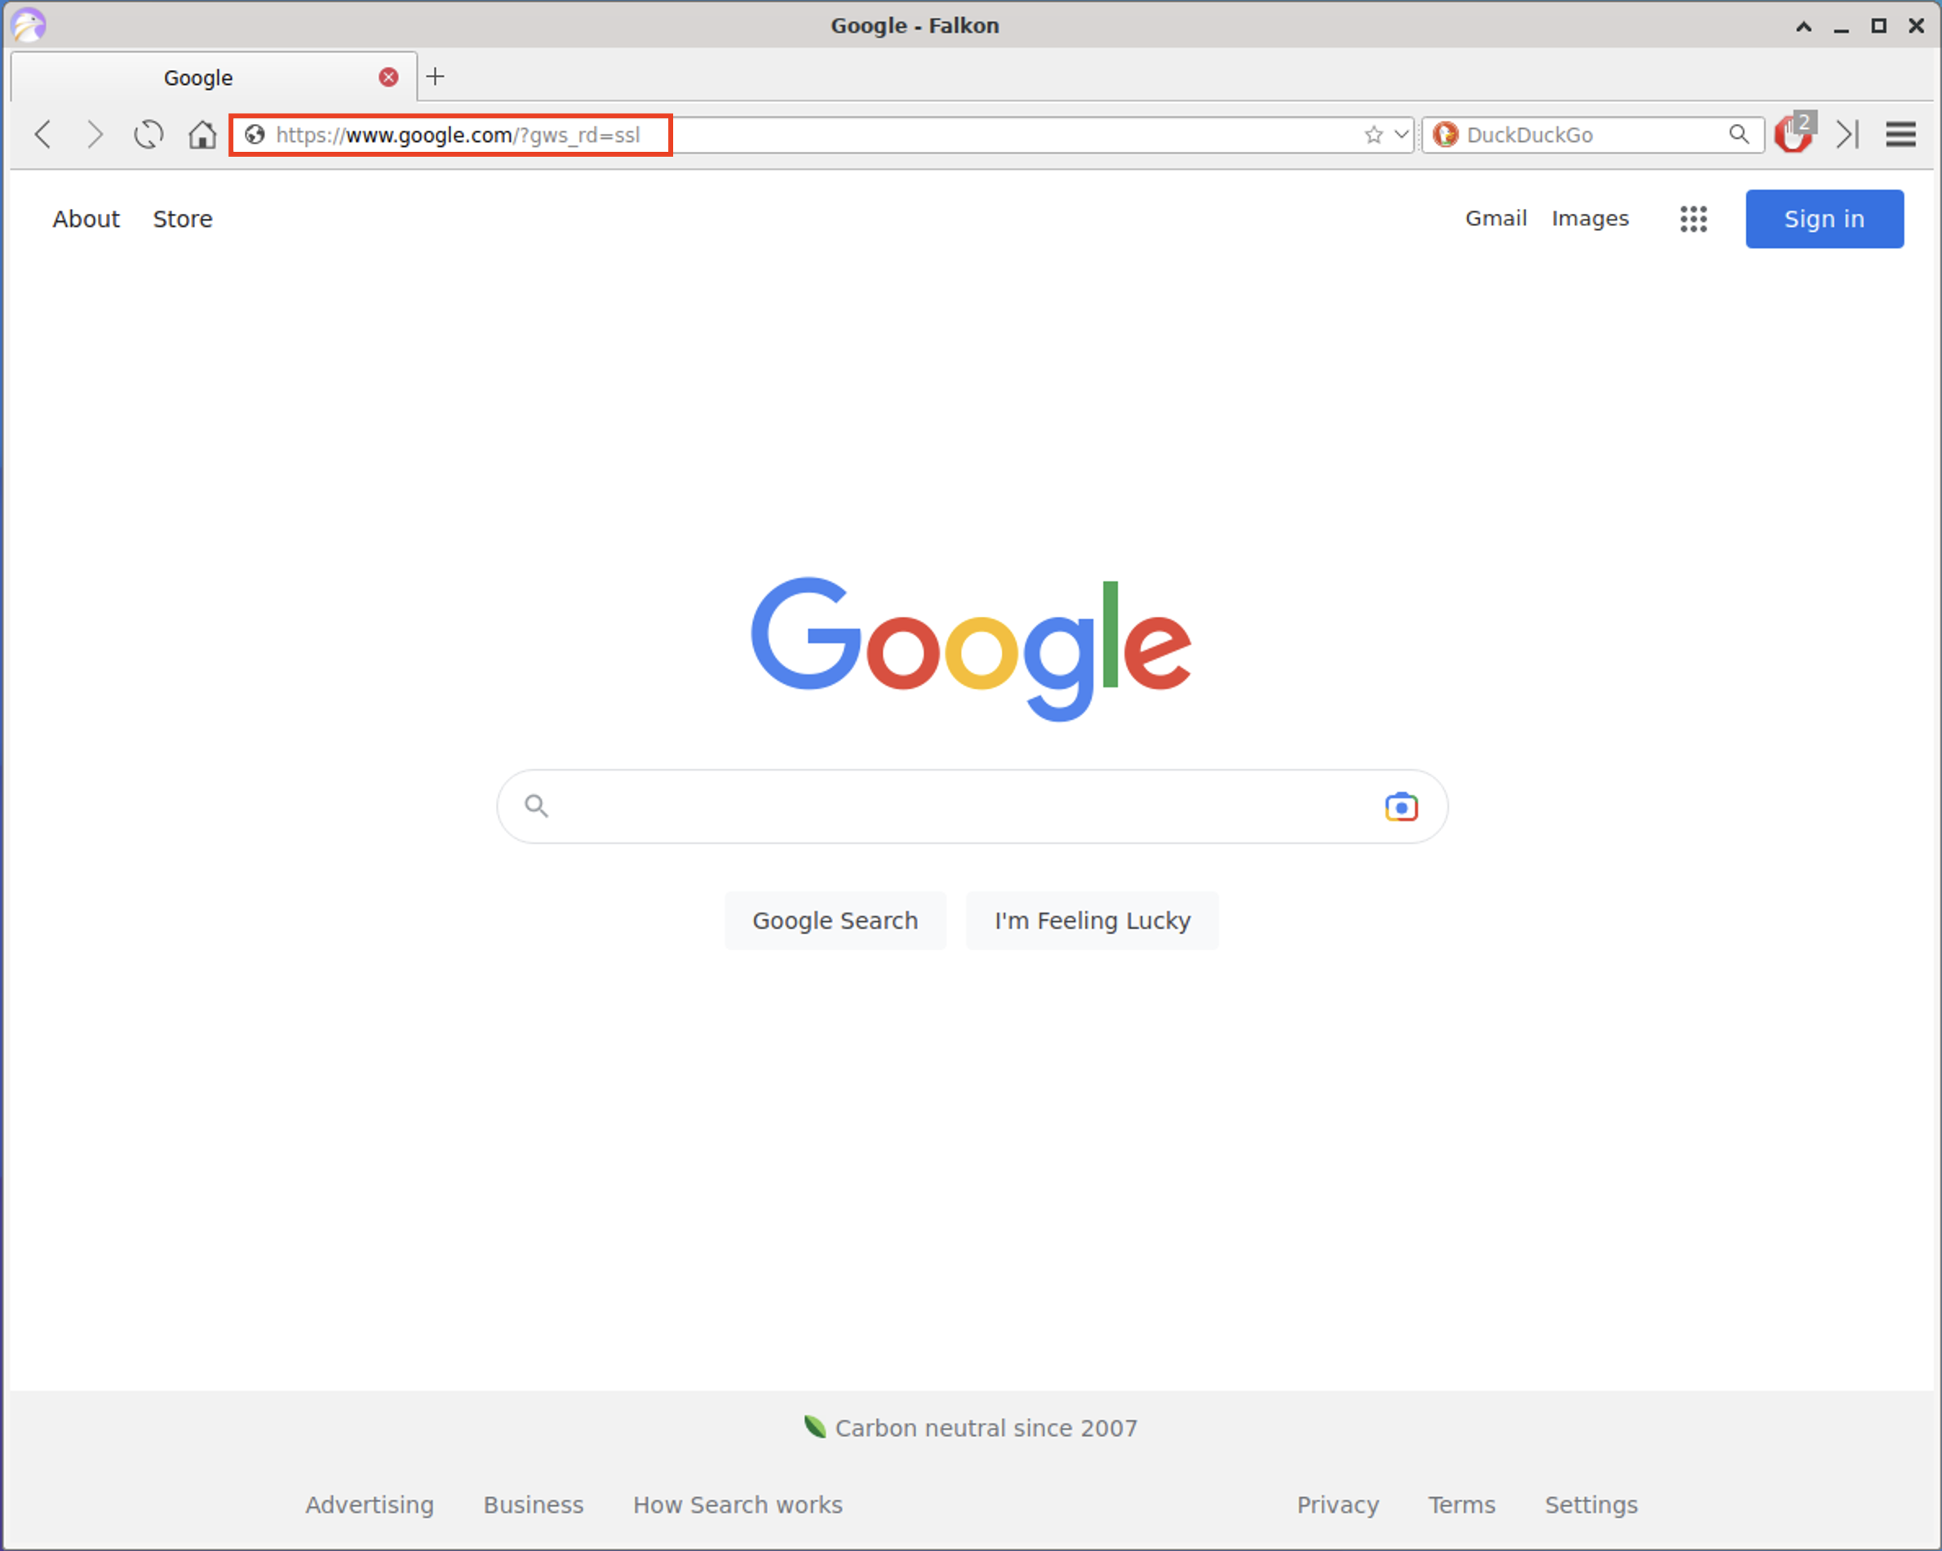
* Let's remove everything at the end after https://www.google.com (the /?gws_rd=ssl part, to make sure we are able to see the main site).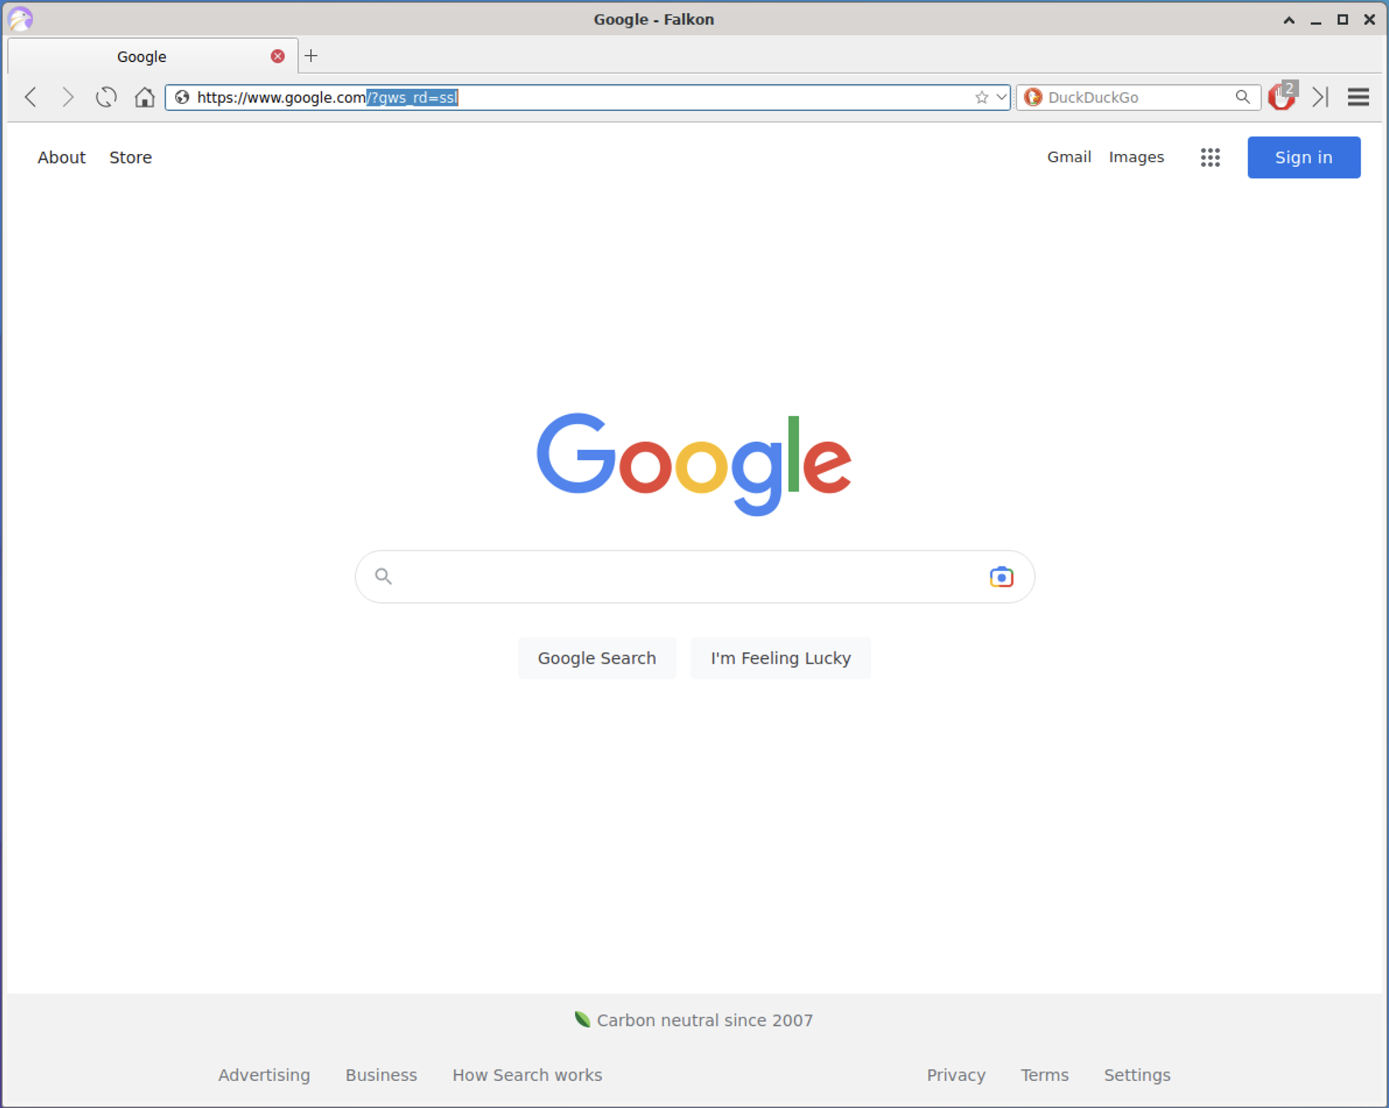
* The web page should show up the same as we saw before, as shown in the image below, and the url will show as https://www.google.com.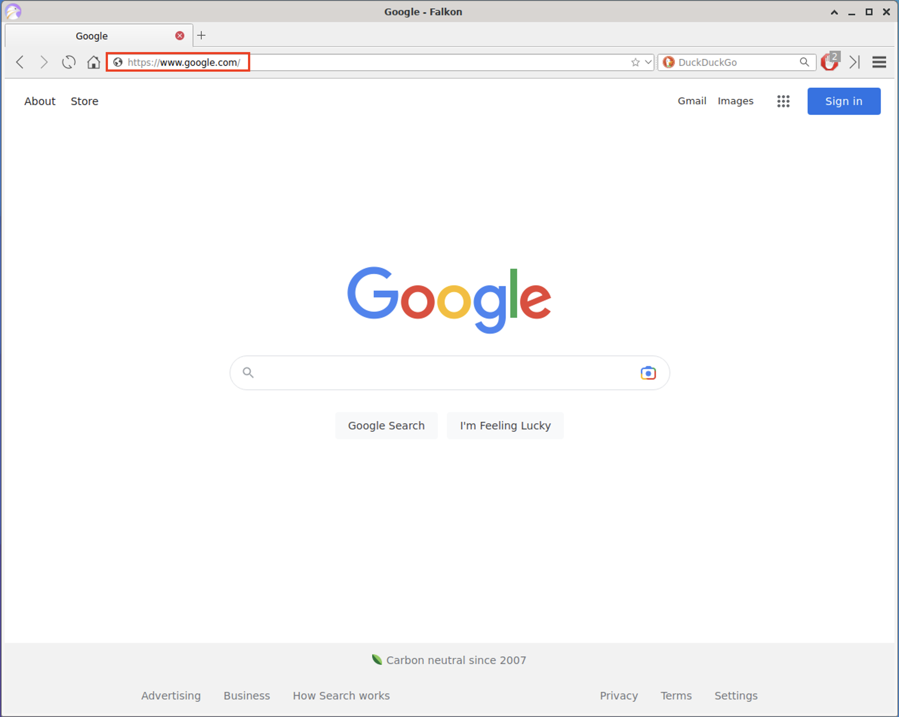
* Next, let's take a look at the Example.com site. In the address bar at the top, type www.example.com.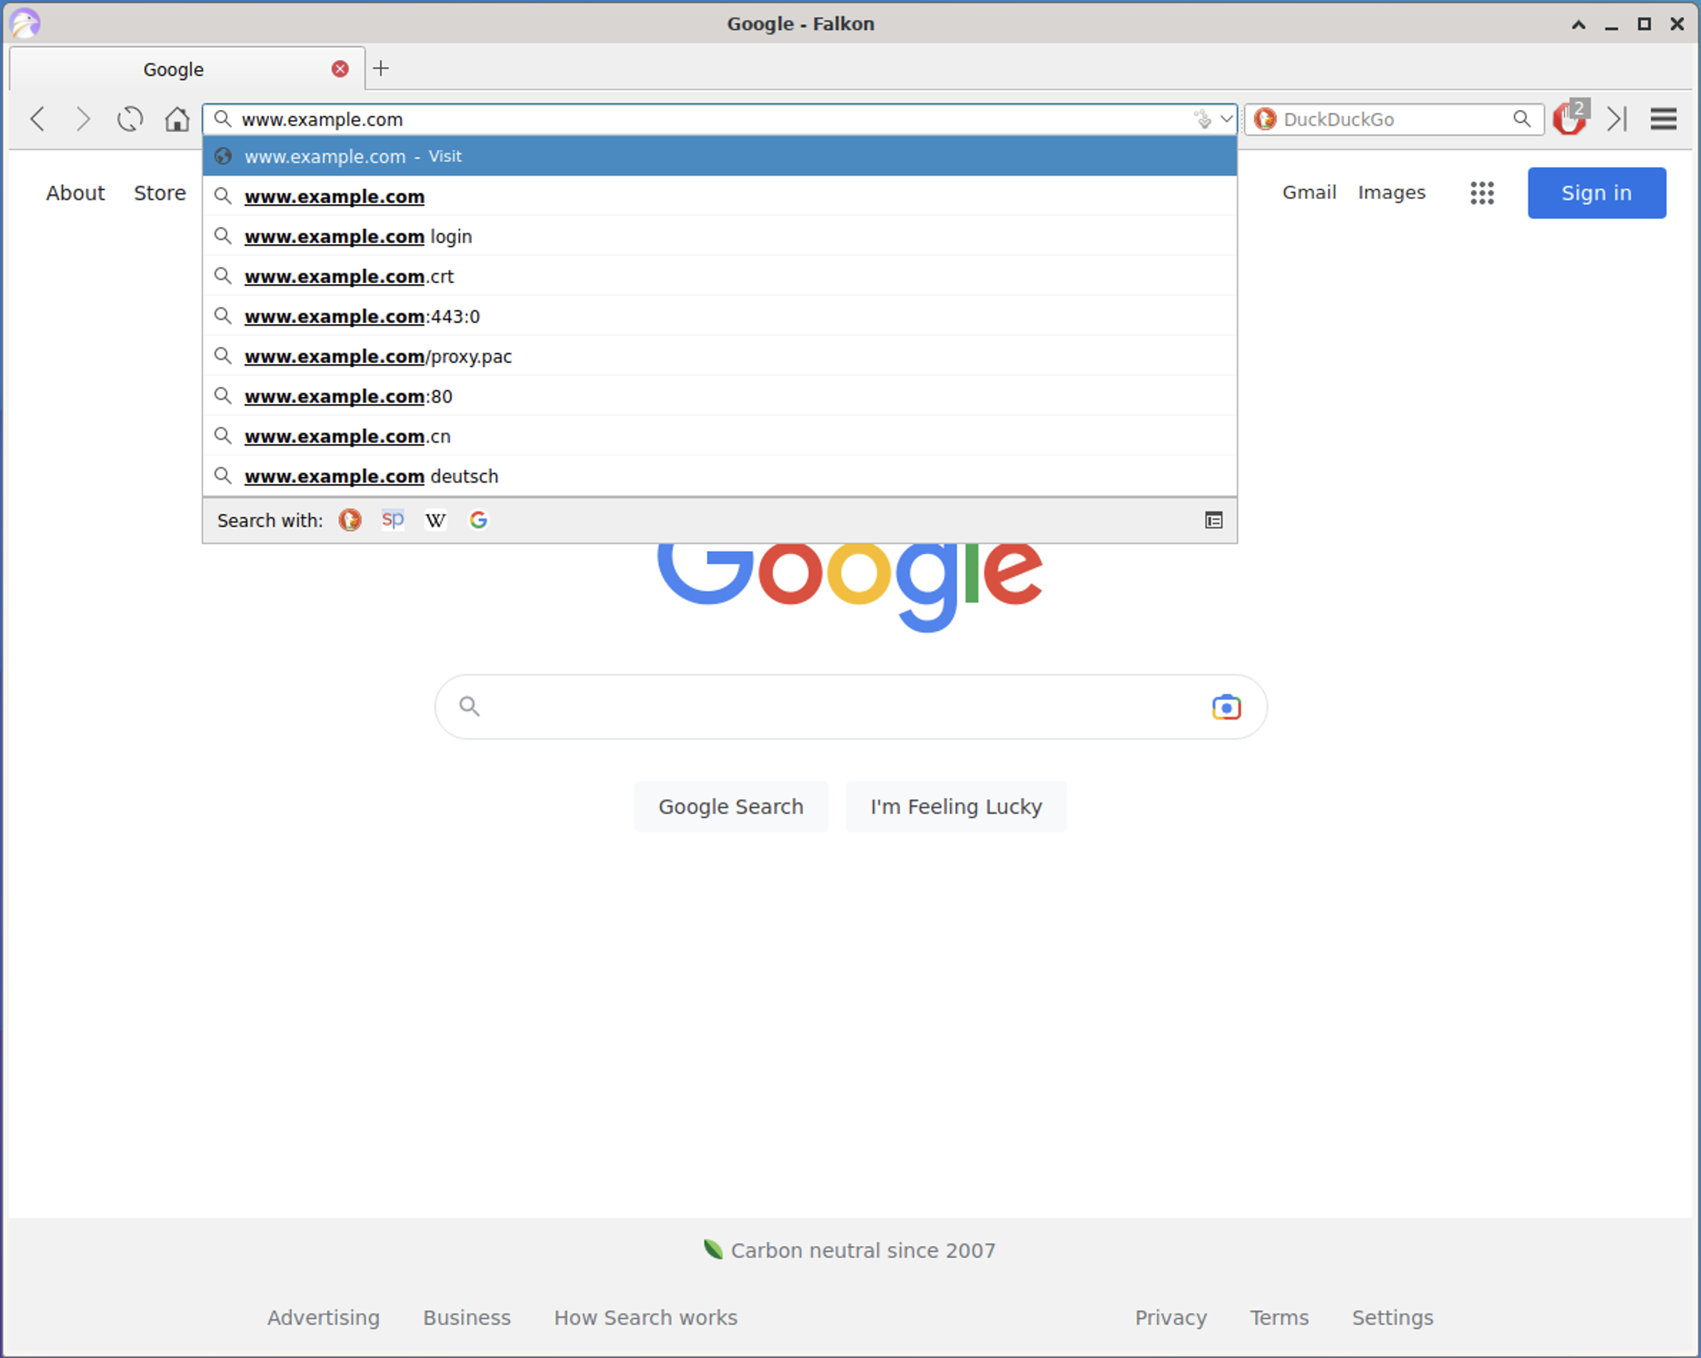
* Press enter in the address bar. It will navigate to www.example.com. Note the url in the address bar that is shown. In this case, it's showing https://www.example.com/.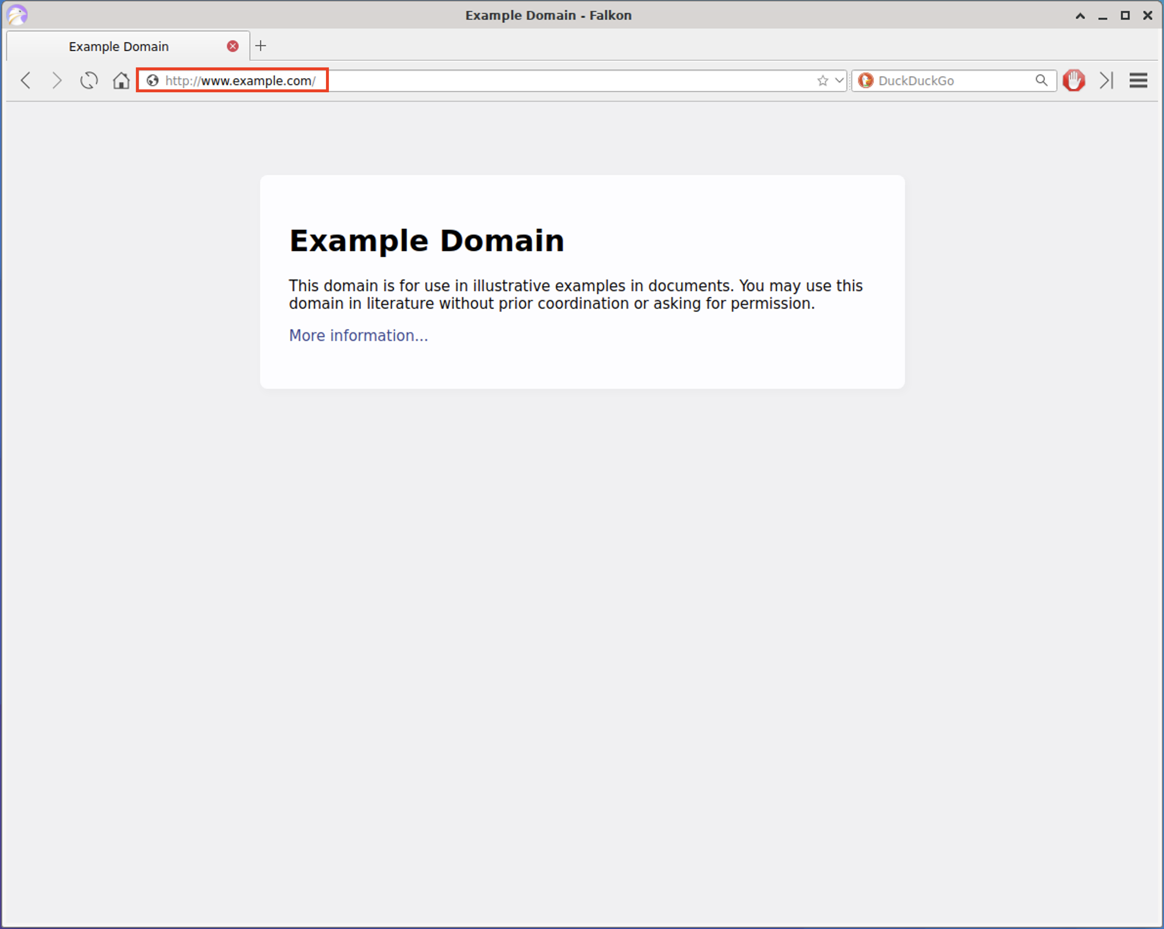

🎯 **Checkpoint 4**: You've been able to try out a few different commands in the terminal:

1. cd ~ to go to the home directory,
2. pwd to print the working directory,
3. ls to list the contents of the current directory,
4. cd <folder> to navigate into a directory,
5. cd .. to go up one directory (**parent** directory), and
6. nano to open up a file in a text editor.

These commands will be ones that you will use often when working in the command line. Feel free to refer to this section whenever you need a refresher! 

#### **Step 5: Edit the Hosts file**

Before we make any edits to our hosts file, since we went to the website in our browser, we'll need to clear any history and traces of us visiting them so that we can be sure that we'll be accessing the correct info from the hosts file. Let's change some settings in the browser.

* In the top bar in the Falkon browser is an icon on the top left with three (3) vertical lines (this is often called a hamburger menu icon). Click on it and navigate to History -> Show All History.

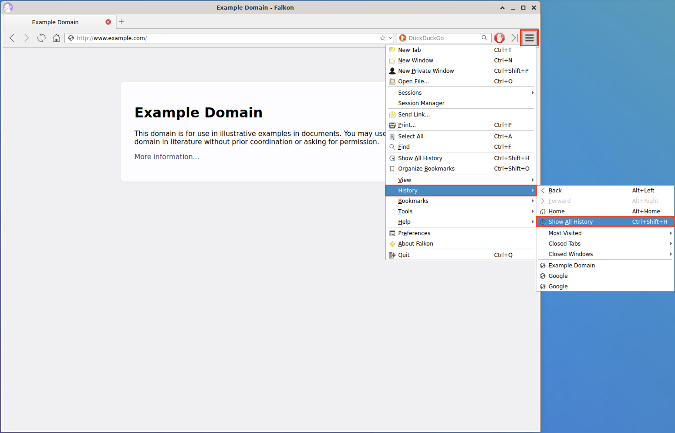

* This will open up a Library menu, which will show the browser history. Click the arrow dropdown menu icon to expand and see more for Today. You should see the websites we have just visited on this list, Example and Google, as shown below:

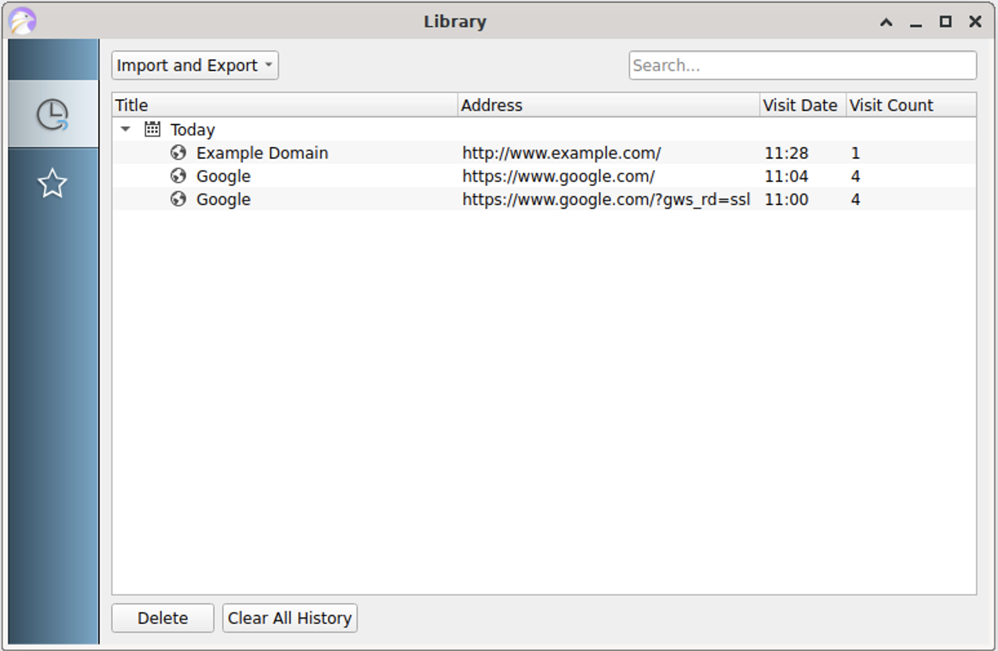

* Next, click on the Clear All History button:

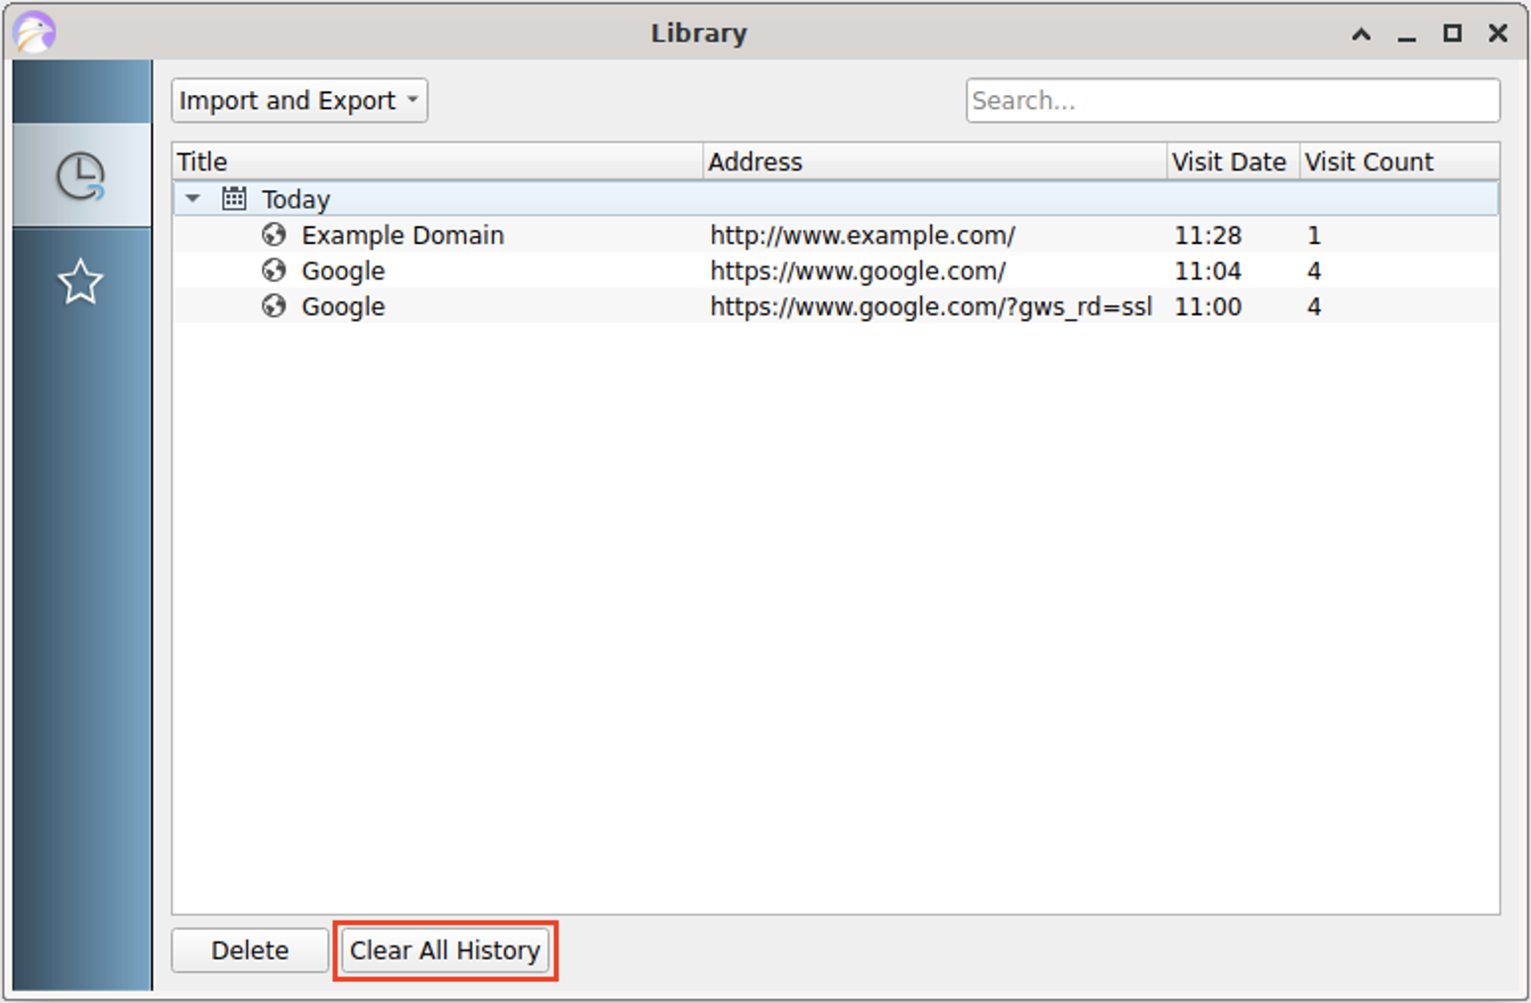

* It will prompt you with a message that says "Are you sure you want to delete all history?". Click on Yes.

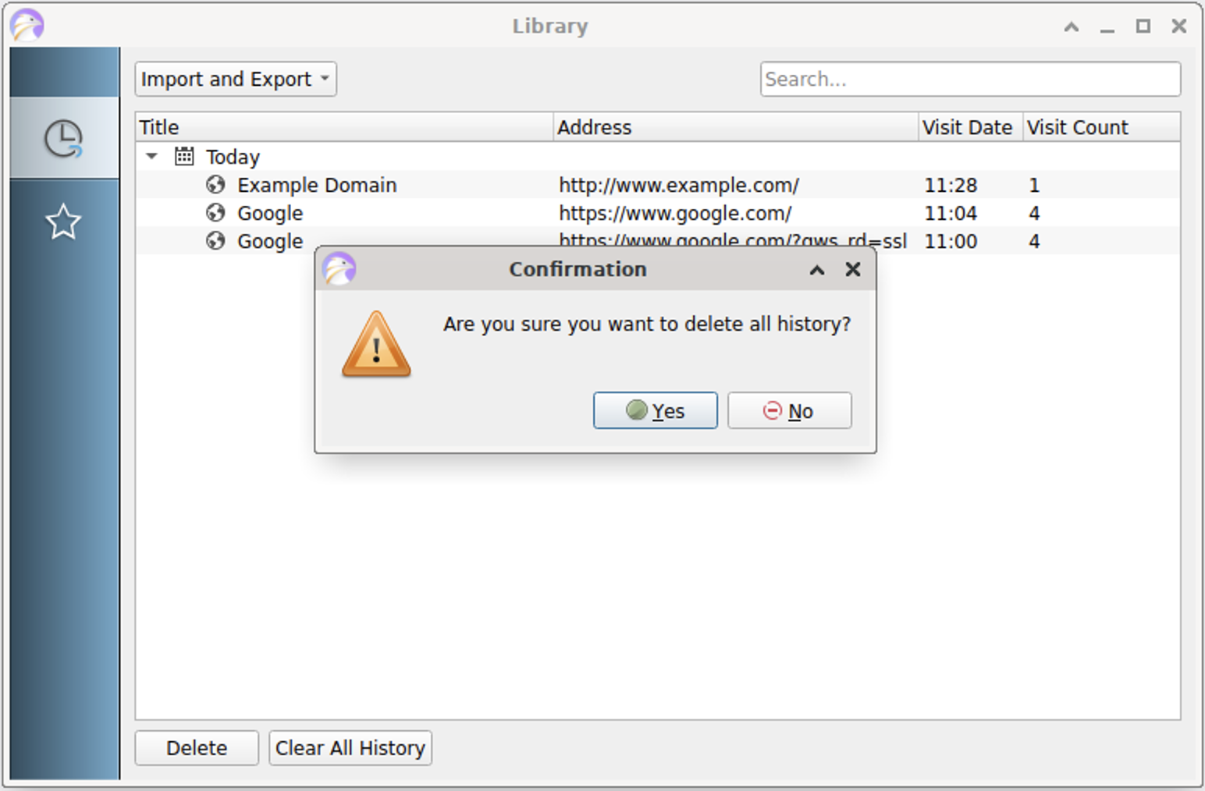

* You should now see all of the history cleared in the menu. This will remove some traces of us having visited the web pages before in the browser. Click the X at the top of the menu to close it.

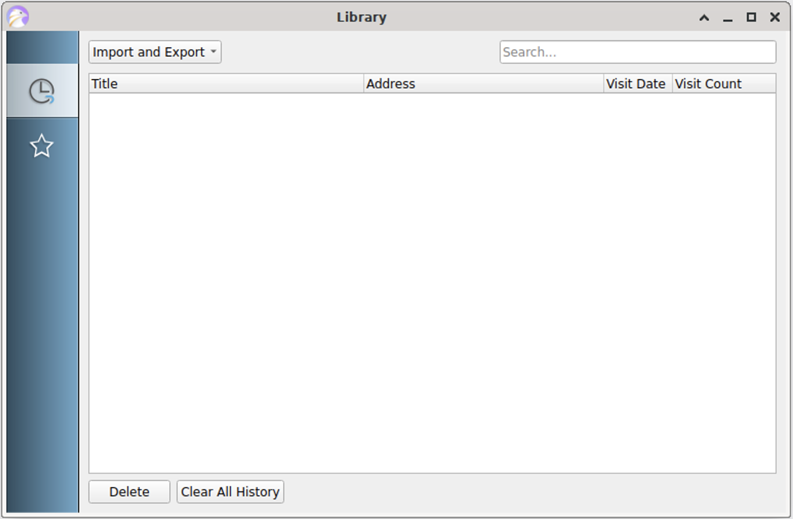

Next, we'll change a few of the browser settings to clear more of the information that's been stored about the pages we visited.

* In the hamburger menu, navigate to Preferences:

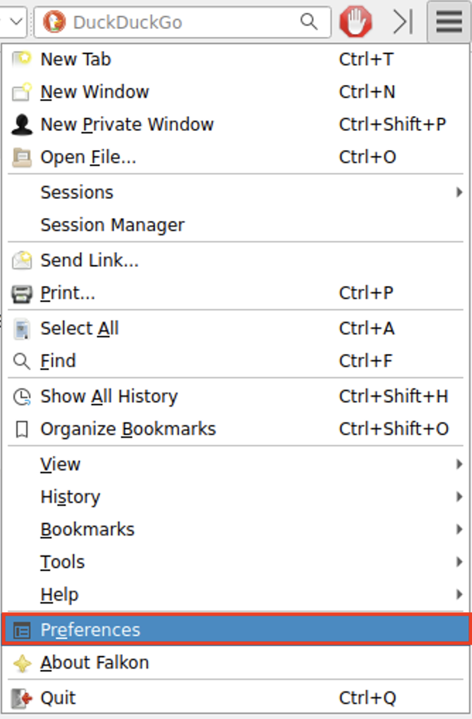

* The Preferences Menu will pop up, and you'll be taken to the General section. Here, we will change the "After Launch" settings.

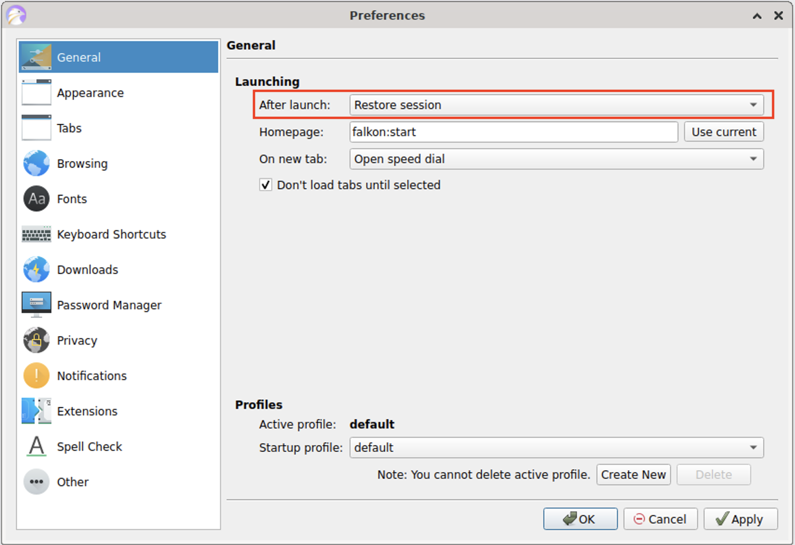

* In the drop down menu, choose "Open homepage". This will open the default home page, which is set to falkon:start (which we saw earlier).

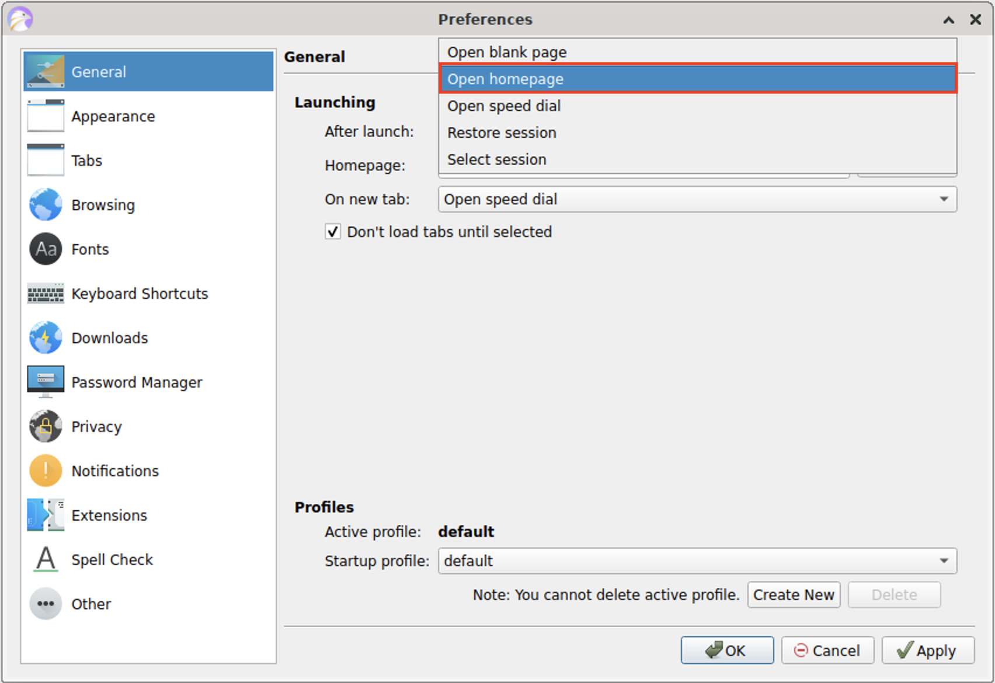

* Once that is selected, click on the "Apply" button to set this setting.

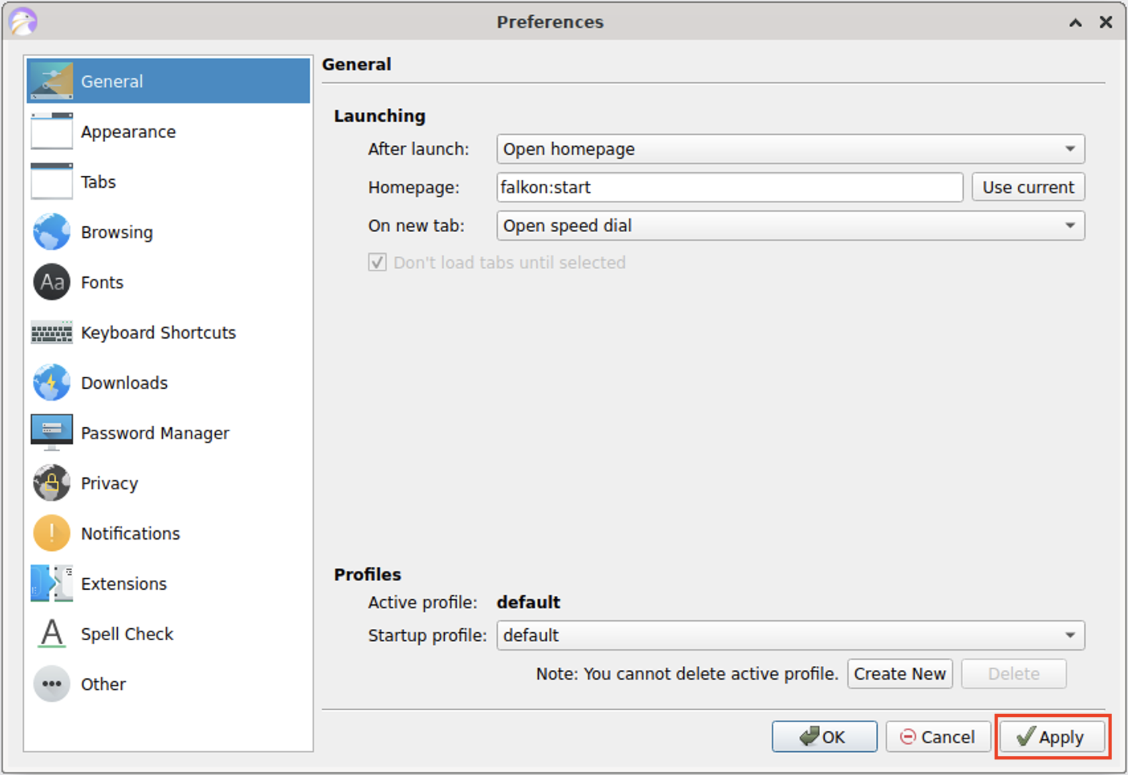

* Next, click on the Browsing section on the left. In the Local Storage tab, we will be changing a few settings.
  + Uncheck the Allow storing network cache on disk.
  + Uncheck Allow saving history.
  + Uncheck Allow local storage of HTML5 web content.
  + Click the Delete Now button next to the Delete locally stored HTML5 web content on close.

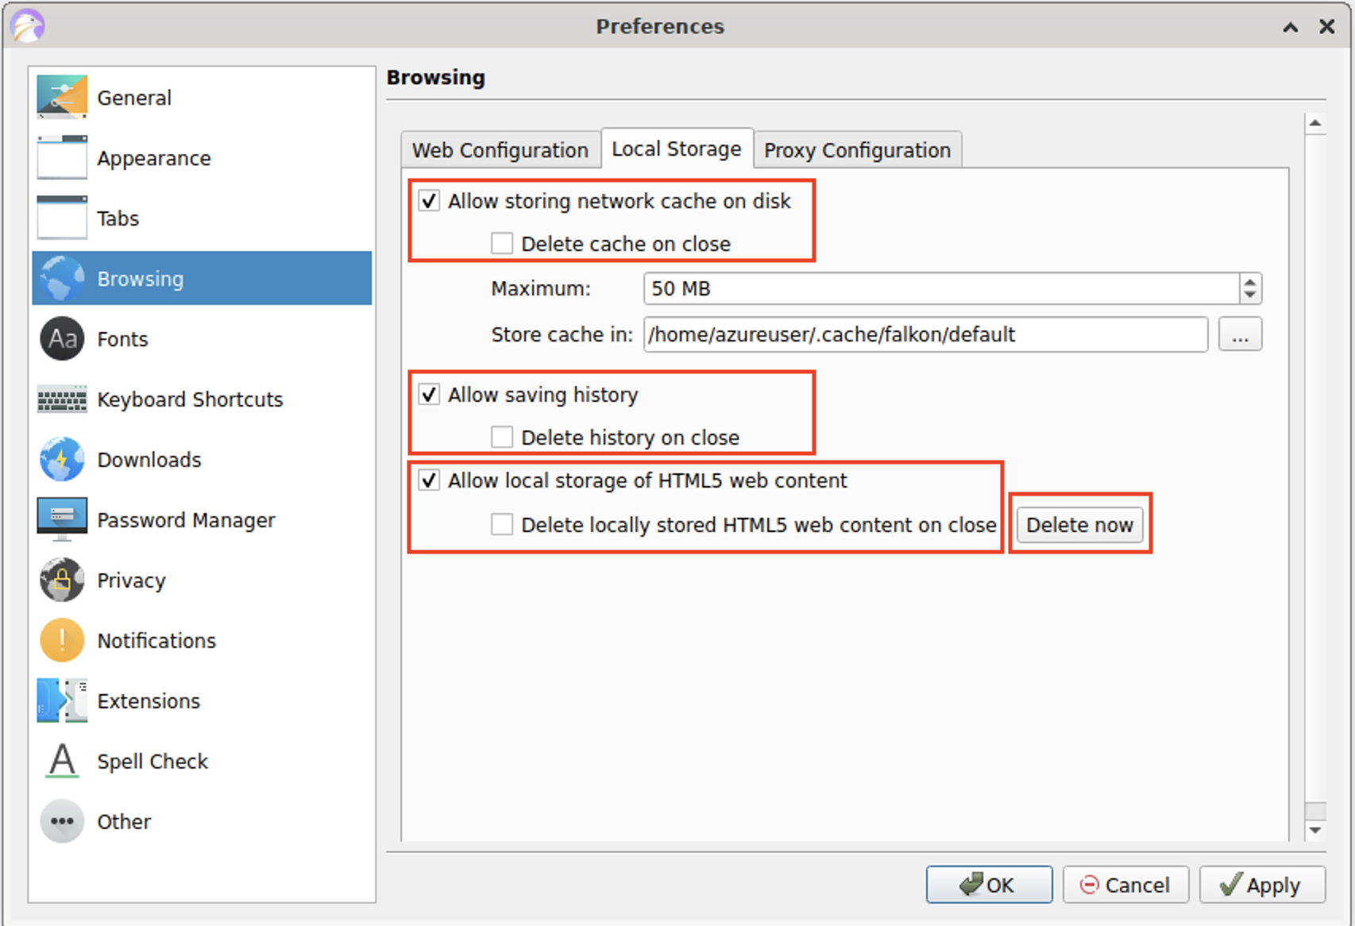

* Your Browsing Settings should look like the image below. After you are done changing these settings, click on the "Apply" button.

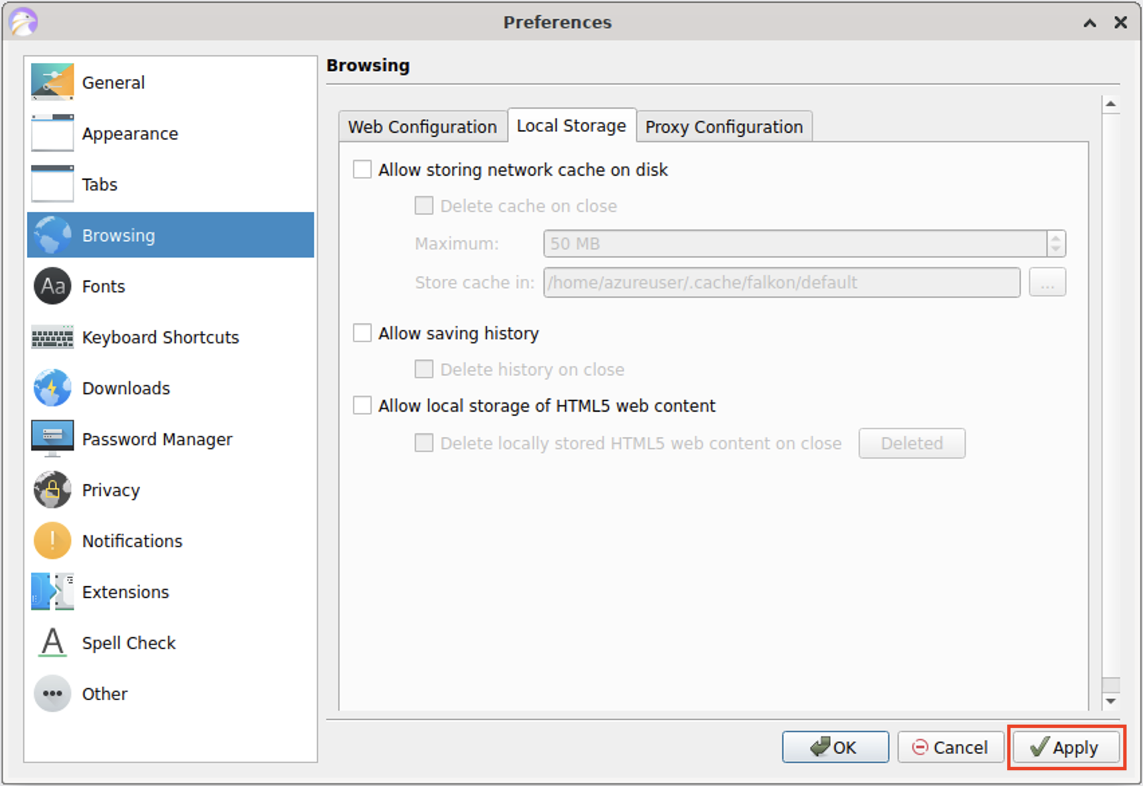

* The last setting we will set will be under the "Privacy" section. In the "Manage Cookies" setting, click on the "Cookies Manager" button.

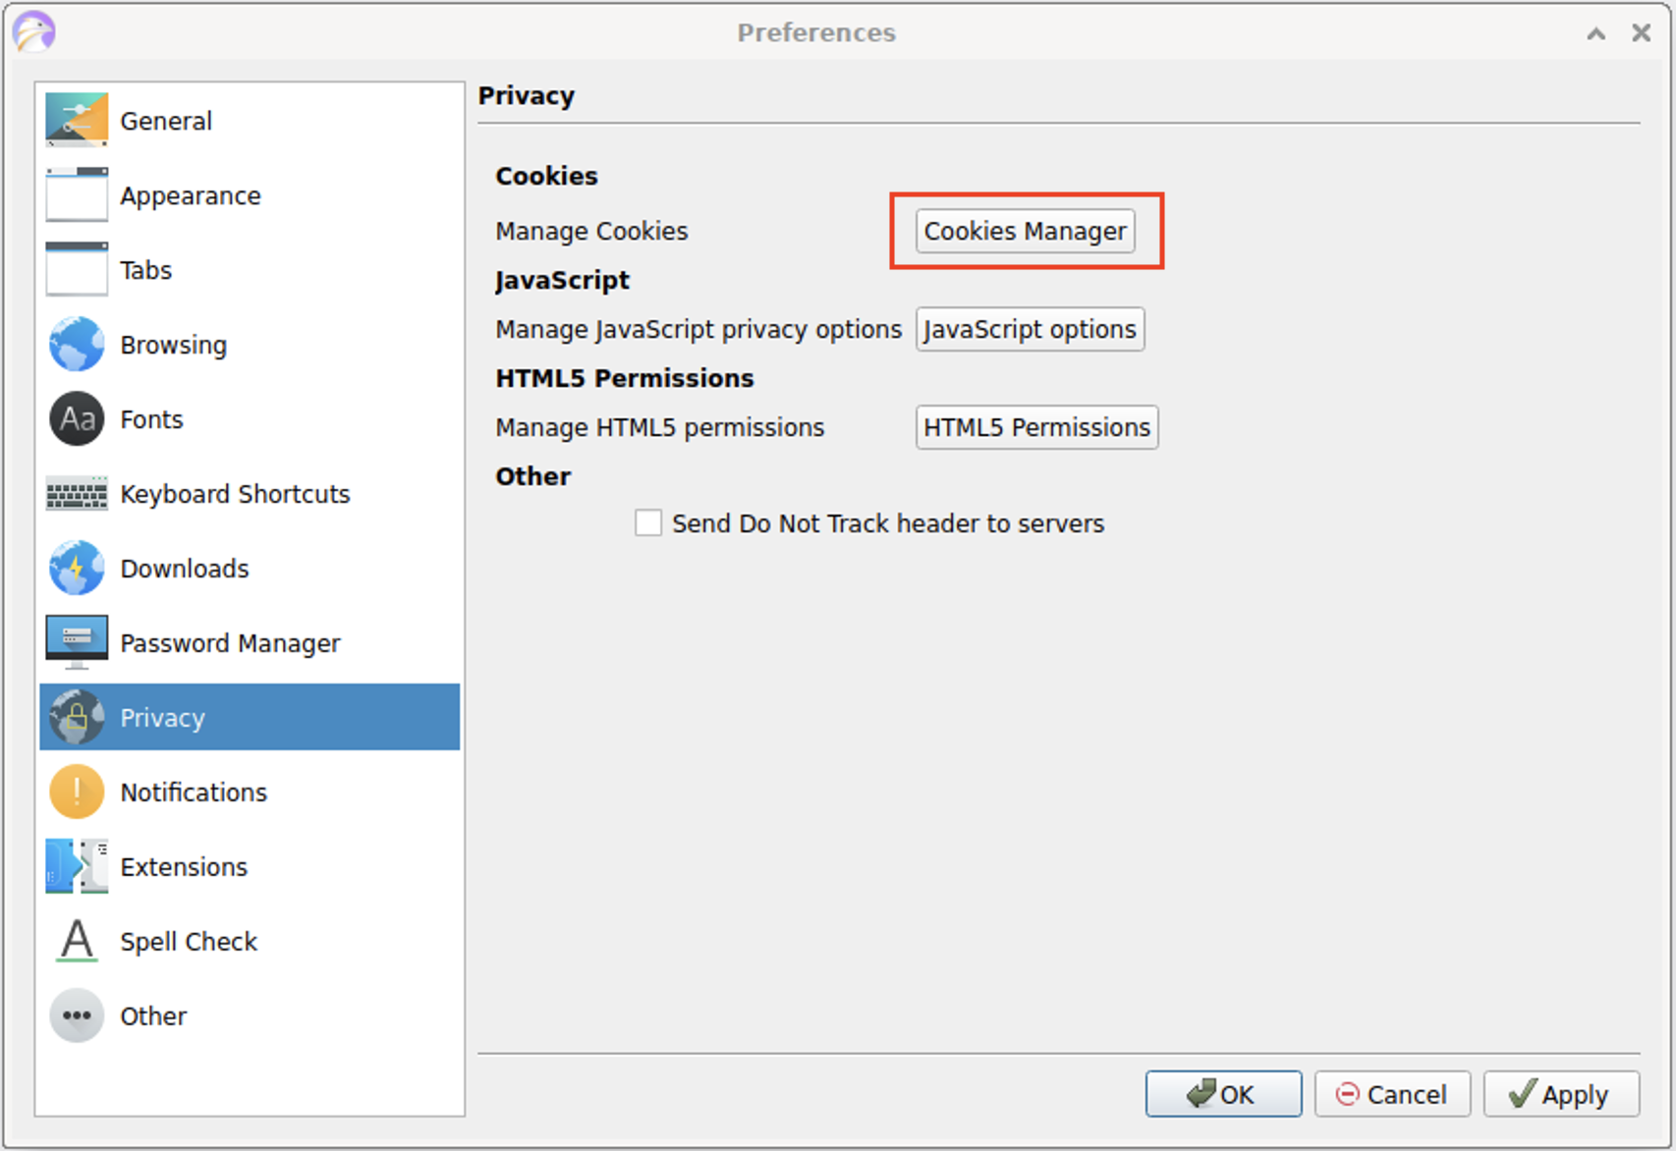

* Under the Cookies Menu, click on the "Remove all cookies". This will delete all the cookies the browser currently has saved.

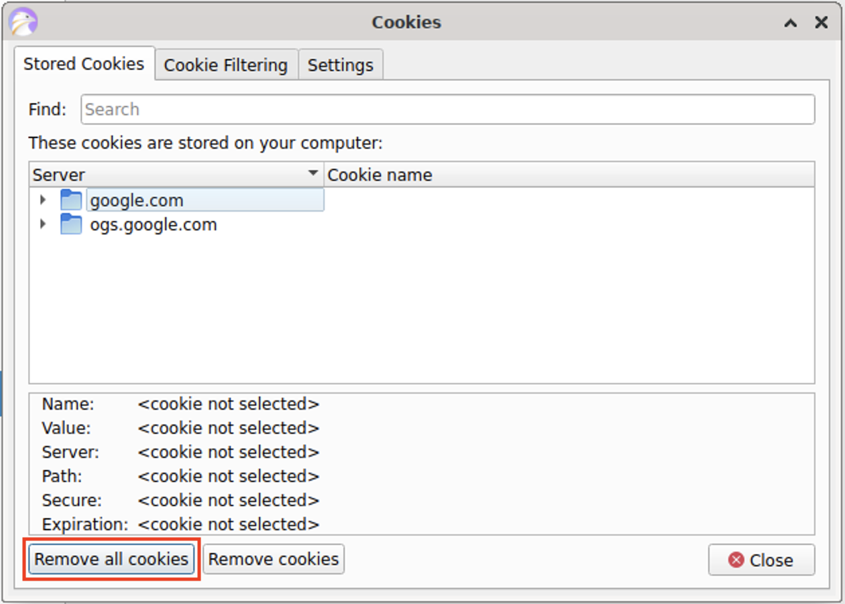

* It will prompt you to confirm that you want to delete all the cookies on your computer. Click on the "Yes" button.

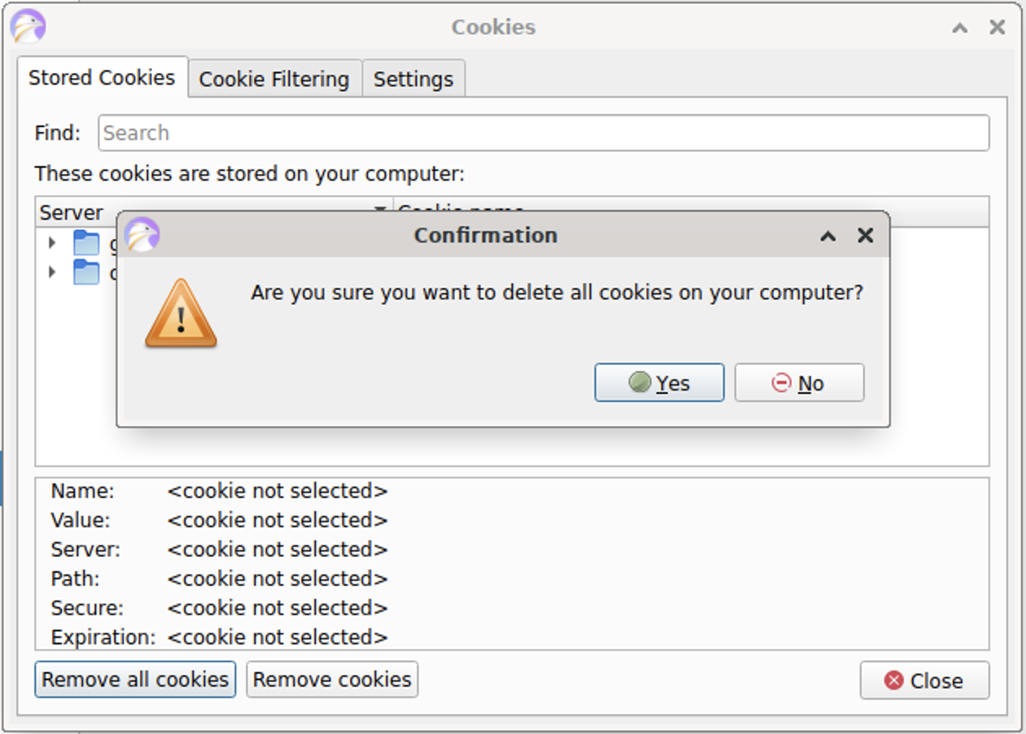

* The cookies will be cleared! After you are done, click on the "Settings" tab:

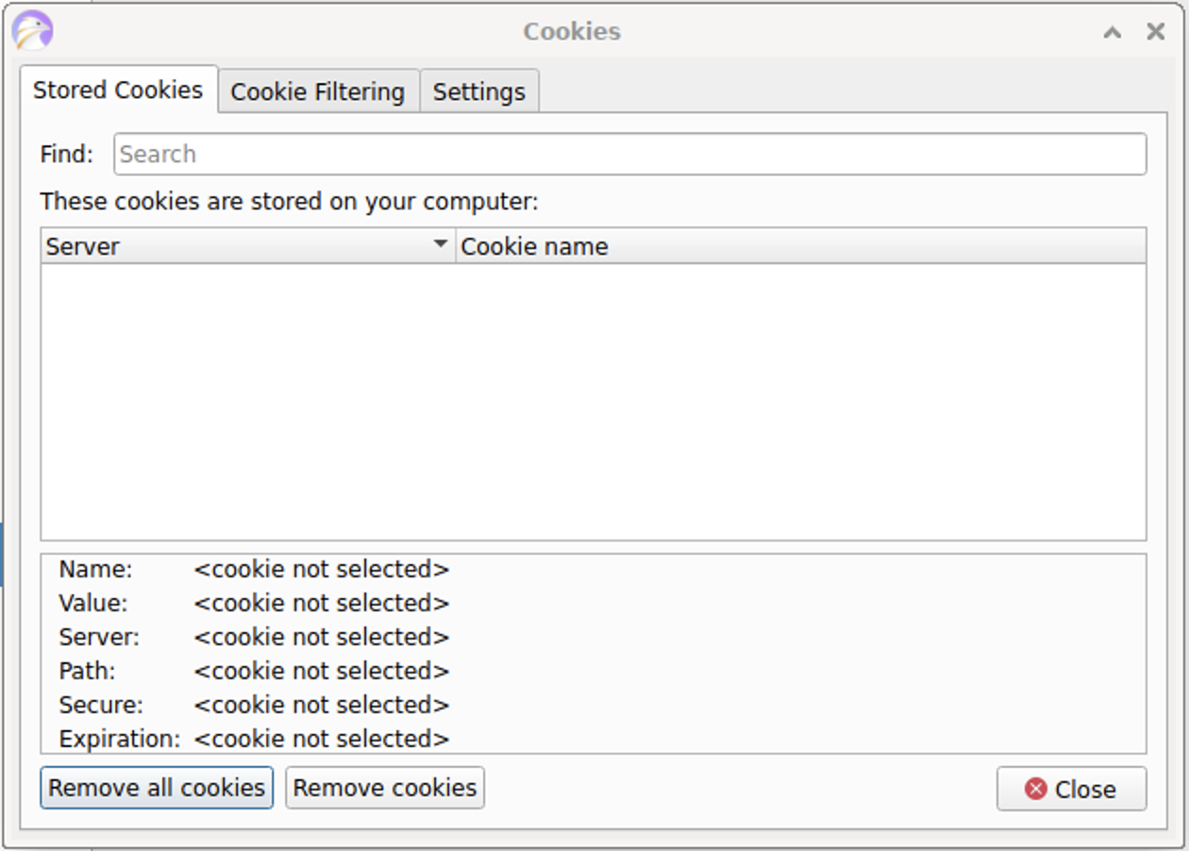

* [] Uncheck the "Allow storing of cookies" setting.

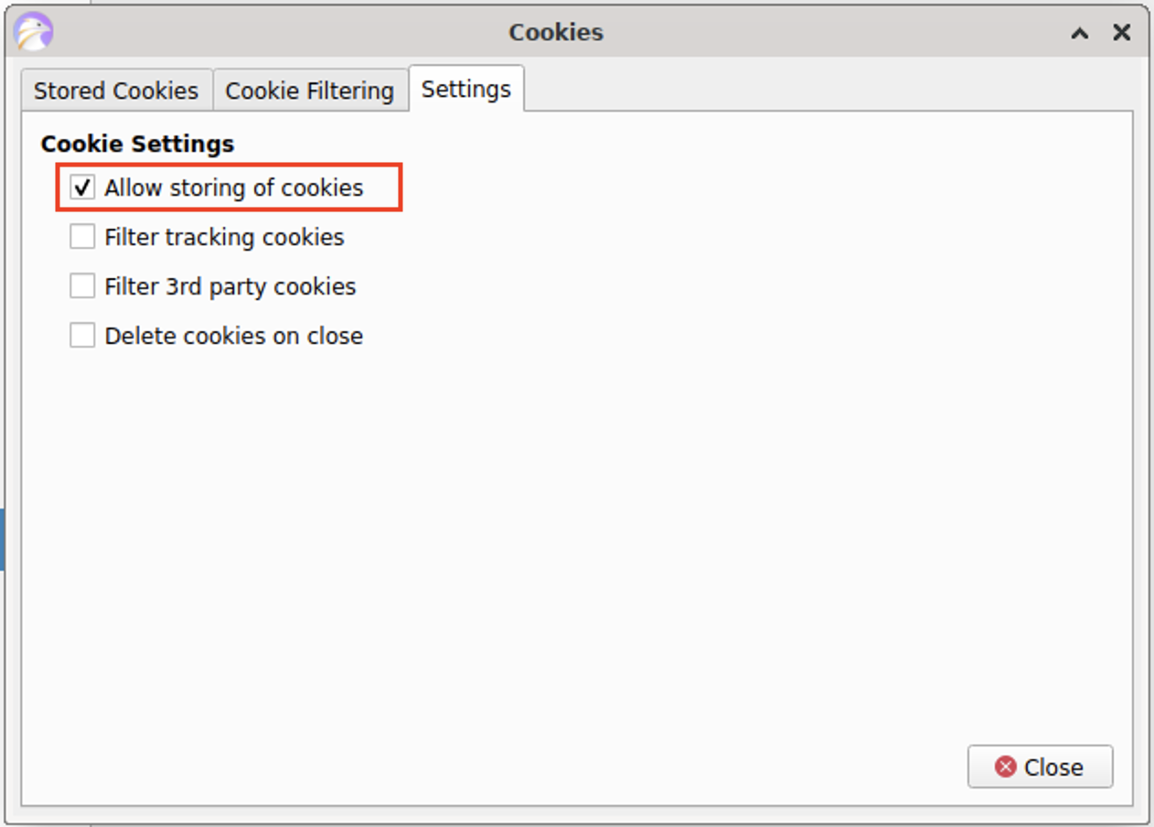

* After you are done, click on the "Close" button.

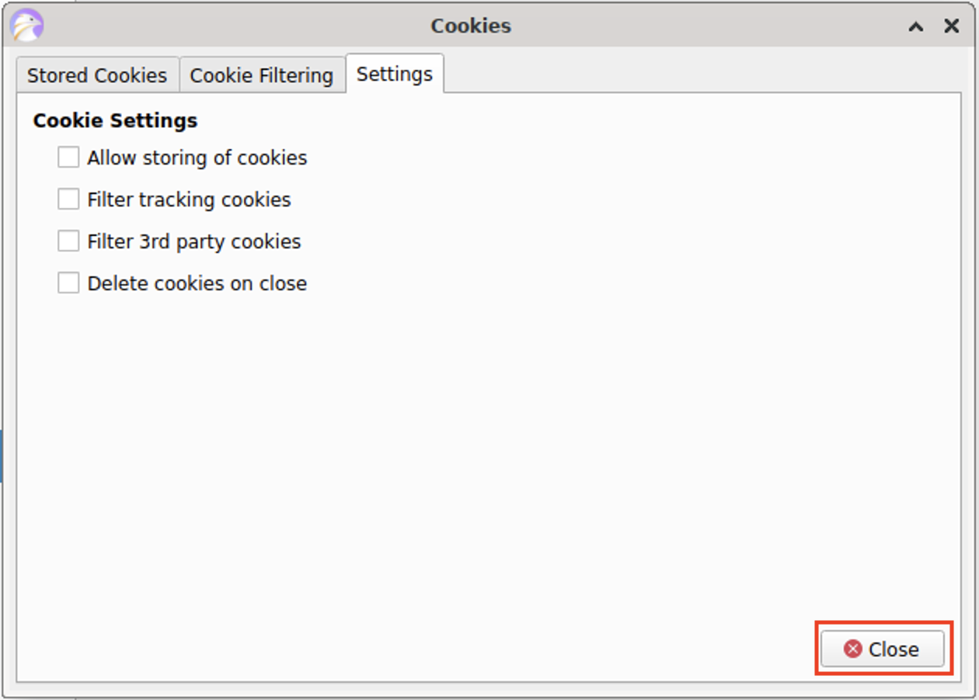

* Back in the Privacy Preferences menu, click on the "Apply" button. After you click on "Apply", click the "Ok" button to close the Preferences menu.

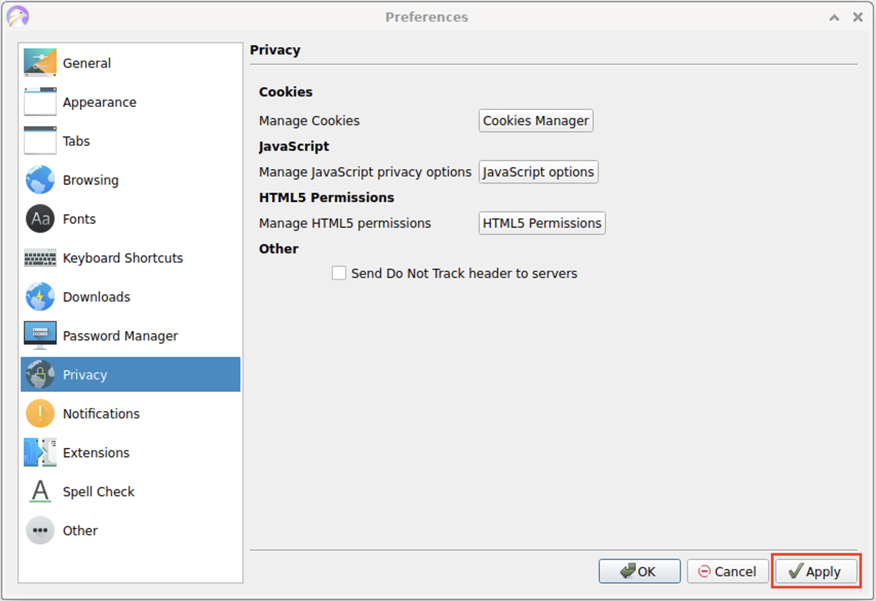

* The very last thing we will do is to clear the recent history. In the hamburger menu, go to Tools -> Clear Recent History:

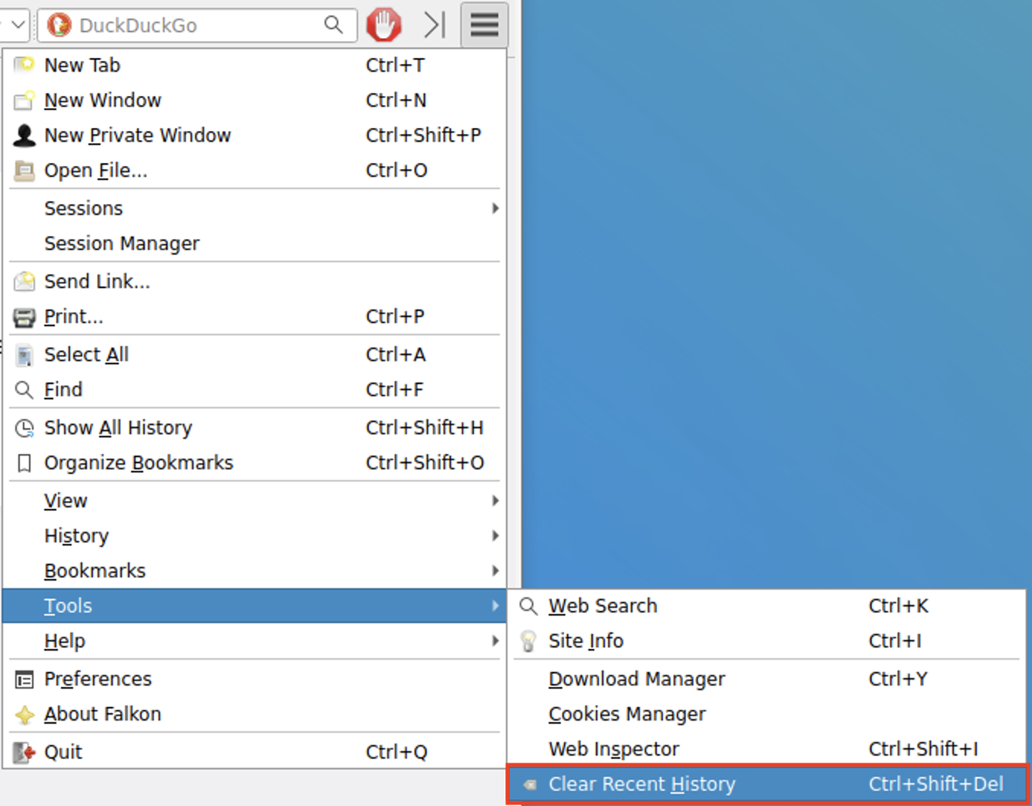

* Make sure that these settings are as follows:
  + Visted pages history from: should be set to "All". This will clear page histories from any time period.
  + Web databases, Local storage, Cache, and Cookies are all checked.
* Once you have modified these settings, click on the "Clear" button. The button will change to "Done" and the popup window will close itself.

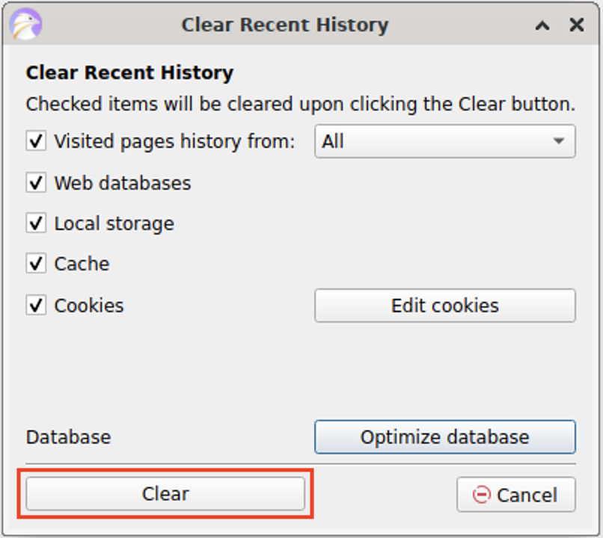

* Close the browser window once you are done with all the changes.

🎯 **Checkpoint 5**: Nice work! You've just edited a couple of settings in the browser to help prevent it from using locally stored data from before that might affect our results. Now we can move on to modifying the hosts file!

#### **Step 6: Edit the Hosts file**

* Back in our terminal window where we opened the hosts file, we'll start to make some edits. take a look at this file! In order to open it, we can use nano text editor again with one slight change. Type:

sudo nano hosts

Adding sudo in front of the command we used before will allow us to modify this file. It should no longer show the warning from before when the file opens: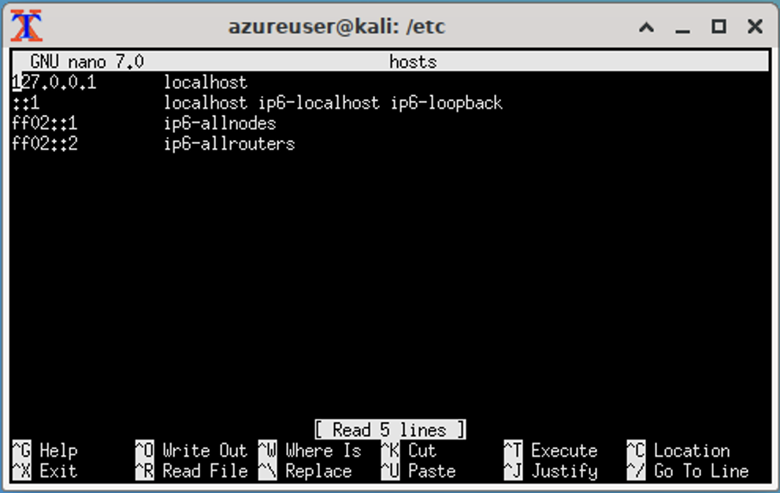

* Move your cursor to the bottom of the file by using the down arrow on your keyboard (place it after the line that has ff02::2). You should see the white cursor as shown below.

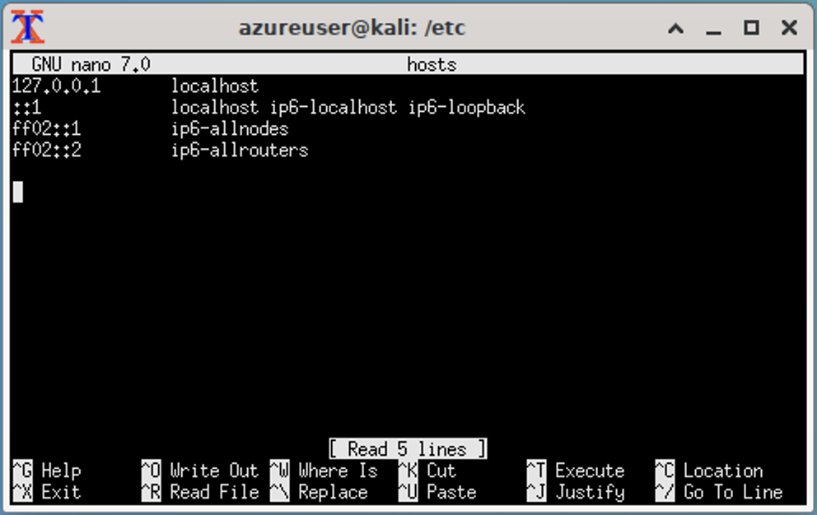

Now, we'll start adding entries to our hosts file for the websites we are testing.

* On the new line, type the IP address we had for www.google.com.
* On the same line, type the website we want to direct it to instead, which is www.example.com.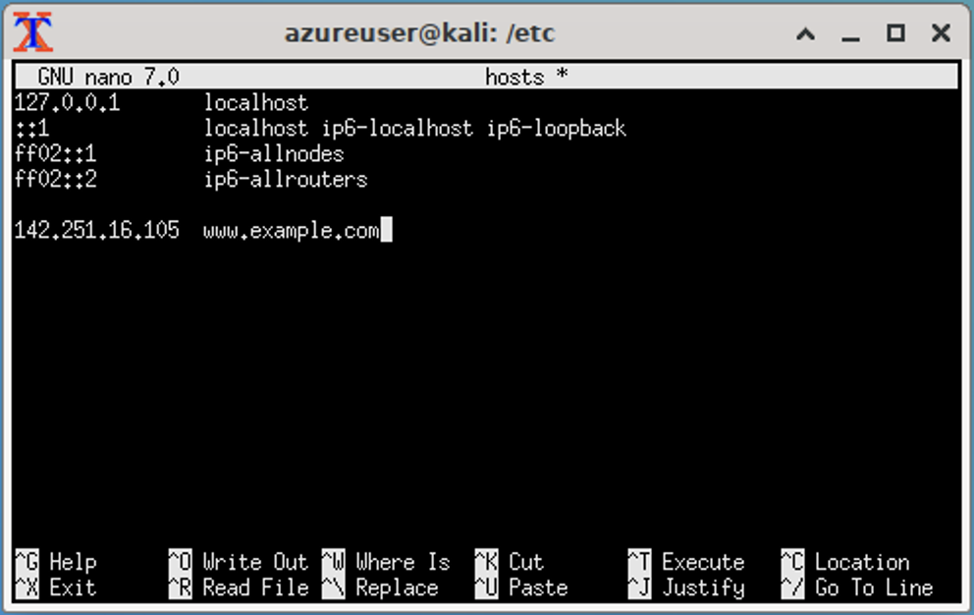
* Press return. On another new line, type the IP address we had for www.example.com.
* On the same line, type Google's Search Engine website url www.google.com.

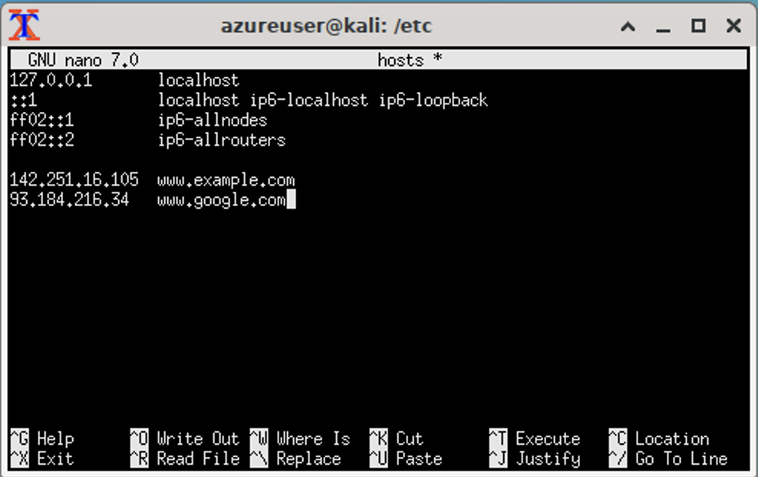

* In order to save our changes, we'll type the command Control+O. This is the Write Out command, which will write these changes to the hosts file. When it asks what "File Name to Write:", leave it as "hosts".

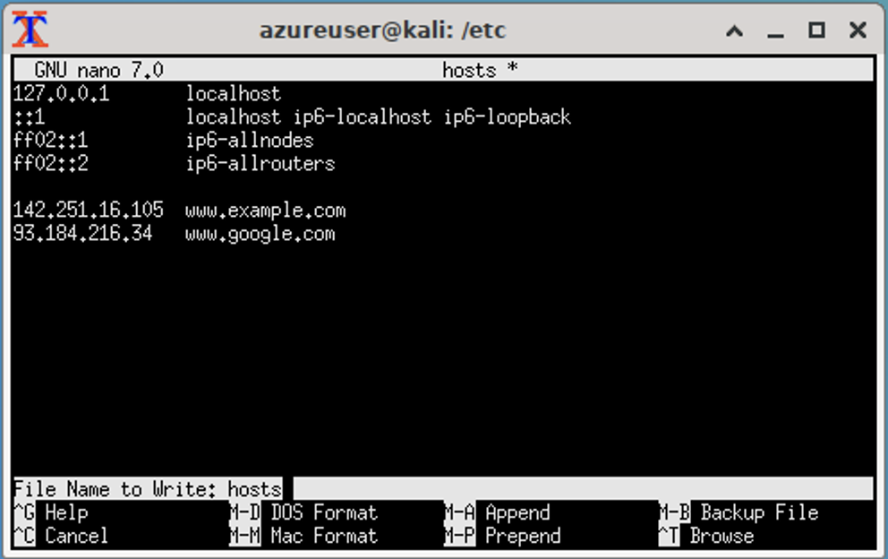

* You'll see a message print out that shows that you wrote some lines! This confirms that the changes you wrote were saved to the file.

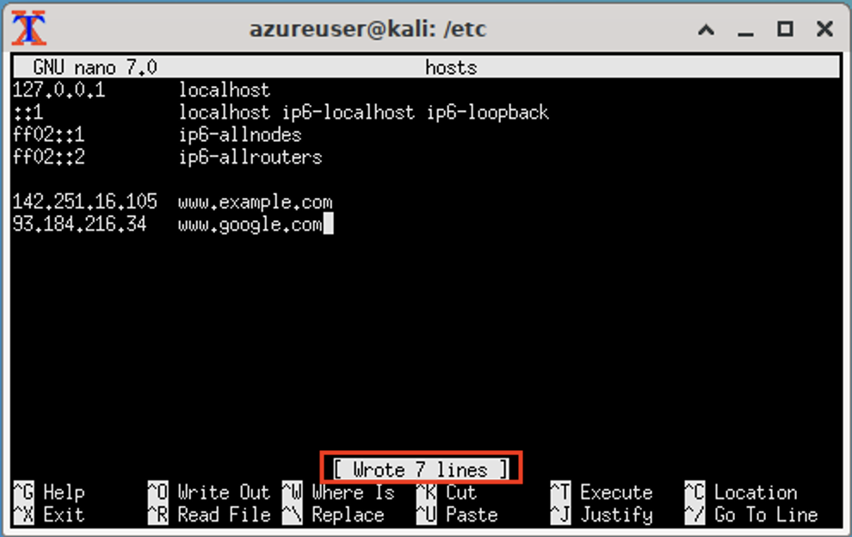

* To close the file, type Control+X. This should exit the file and take you back to the terminal prompt.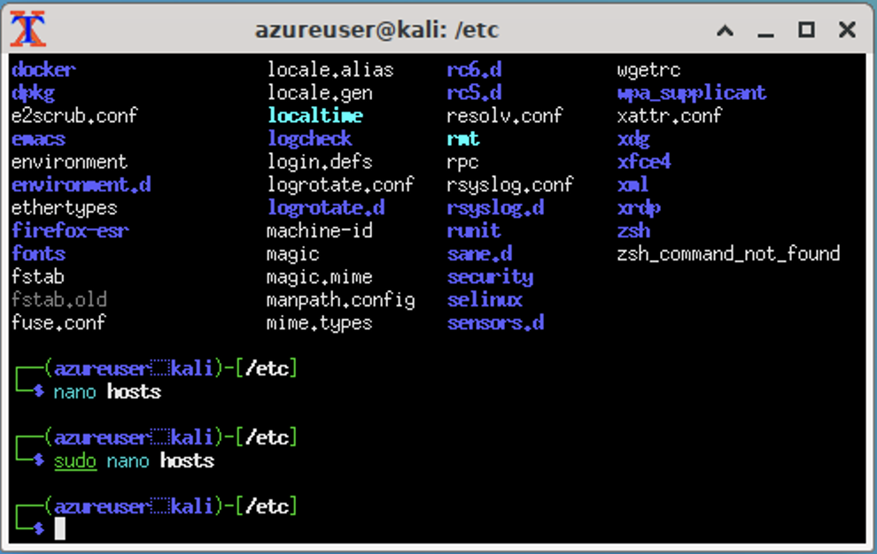

🎯 **Checkpoint 6**: You've edited the hosts file! Now we can test to see our changes.

#### **Step 7: Check the Pings in the Terminal For Changes**

* In the same terminal window, ping www.google.com. Notice how the IP address is now different than before, and it's being redirected to the IP address for www.example.com:

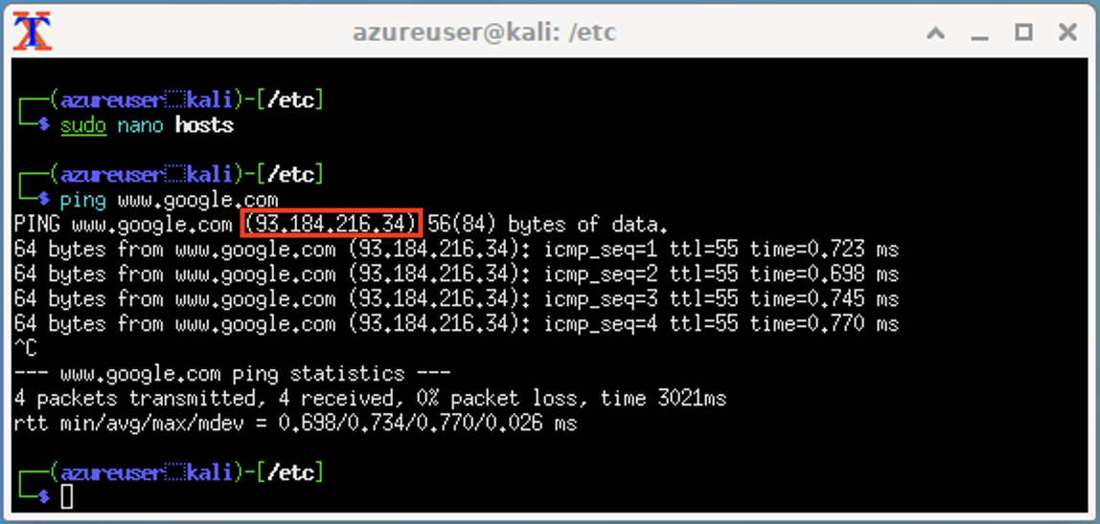- [ ] Try pinging `www.example.com`. Notice how the IP address is now different than before, and it's being redirected to the IP address for `www.google.com`: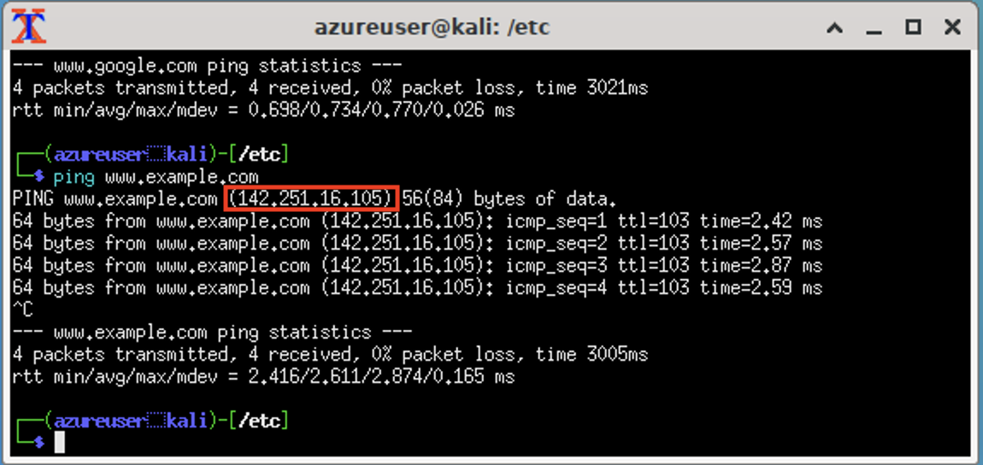

🎯 **Checkpoint 7**: You've been able to verify that we've spoofed the IP addresses for the sites using the hosts file! Now, we'll want to check what kind of behavior we'll see in the browser.

#### **Step 8: Check the Browser For Changes**

* Open a new Falkon browser window. It should take you to the falkon: start page based on the settings we set before.

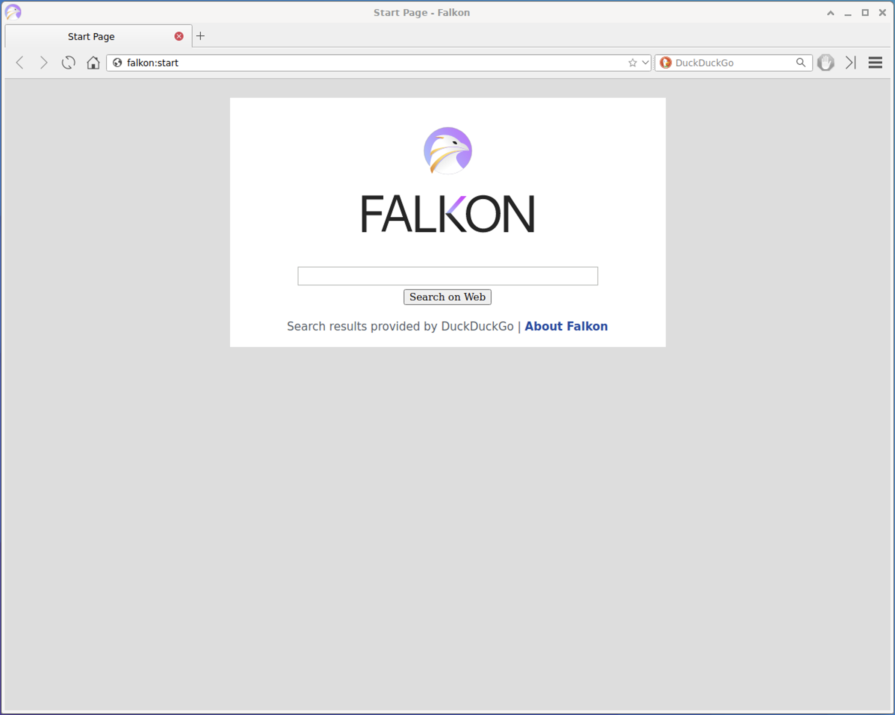

Since we cleared all of the local data for the browser, we should be able to check each of the sites from scratch, and it should be referencing our modified `hosts file.

* Type www.google.com in the address bar and hit Return.

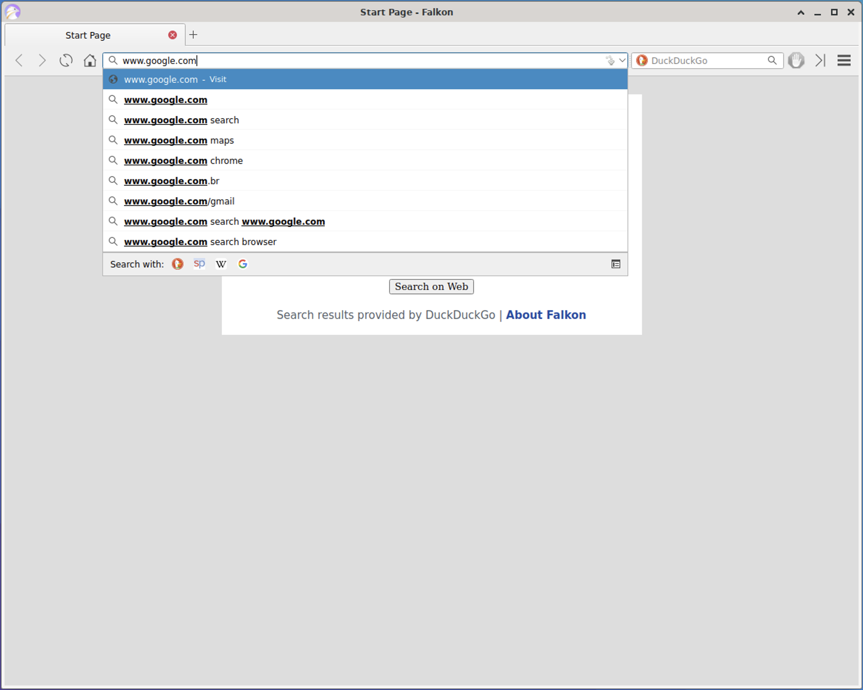

* A 404 - Not Found page should display. Check the url -- this will still show www.google.com.

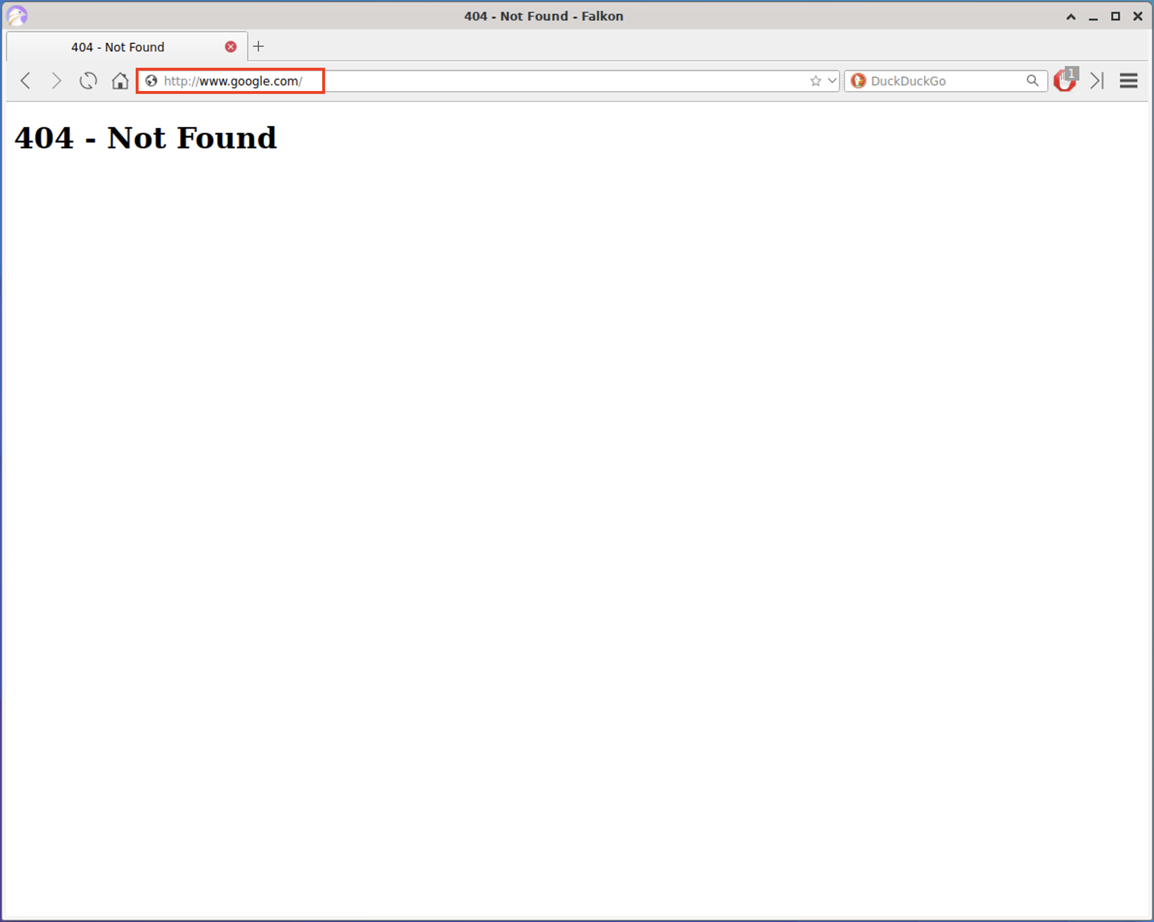

* Now, try typing www.example.com in the address bar.

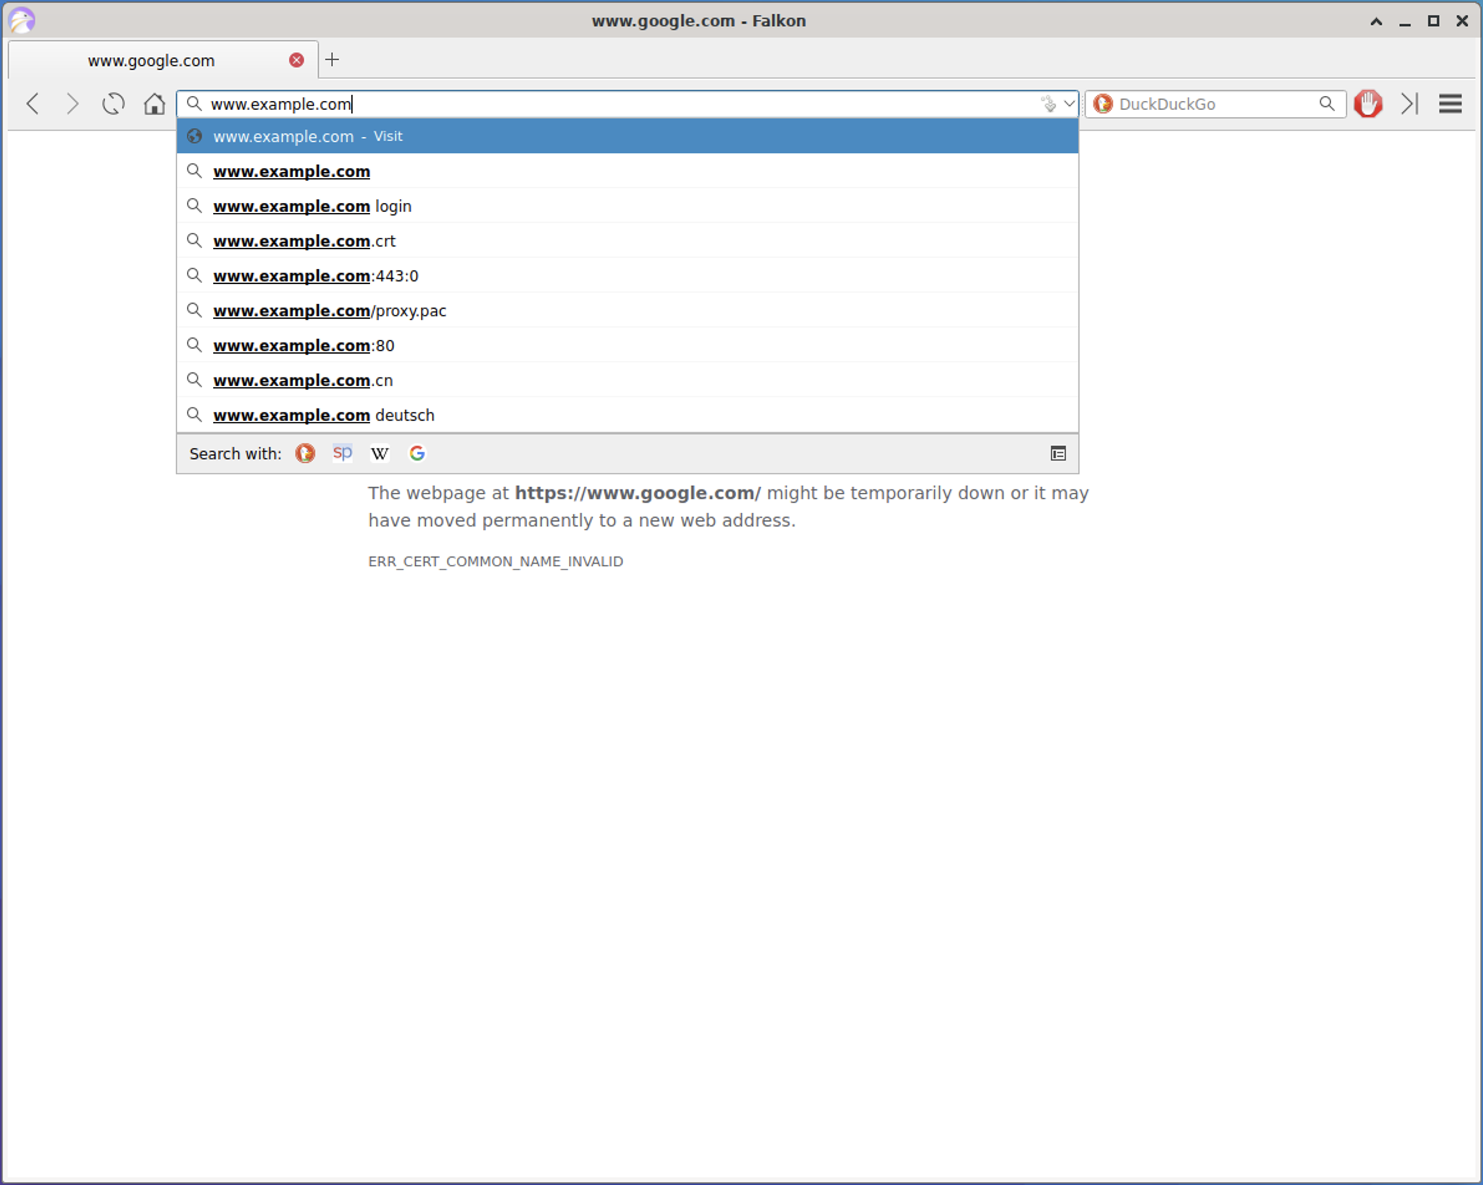

* A 404 - Not Found page should display. Check the url -- this will still show www.example.com, yet is showing a Google server error page, so we know that we are being redirected to a Google server.

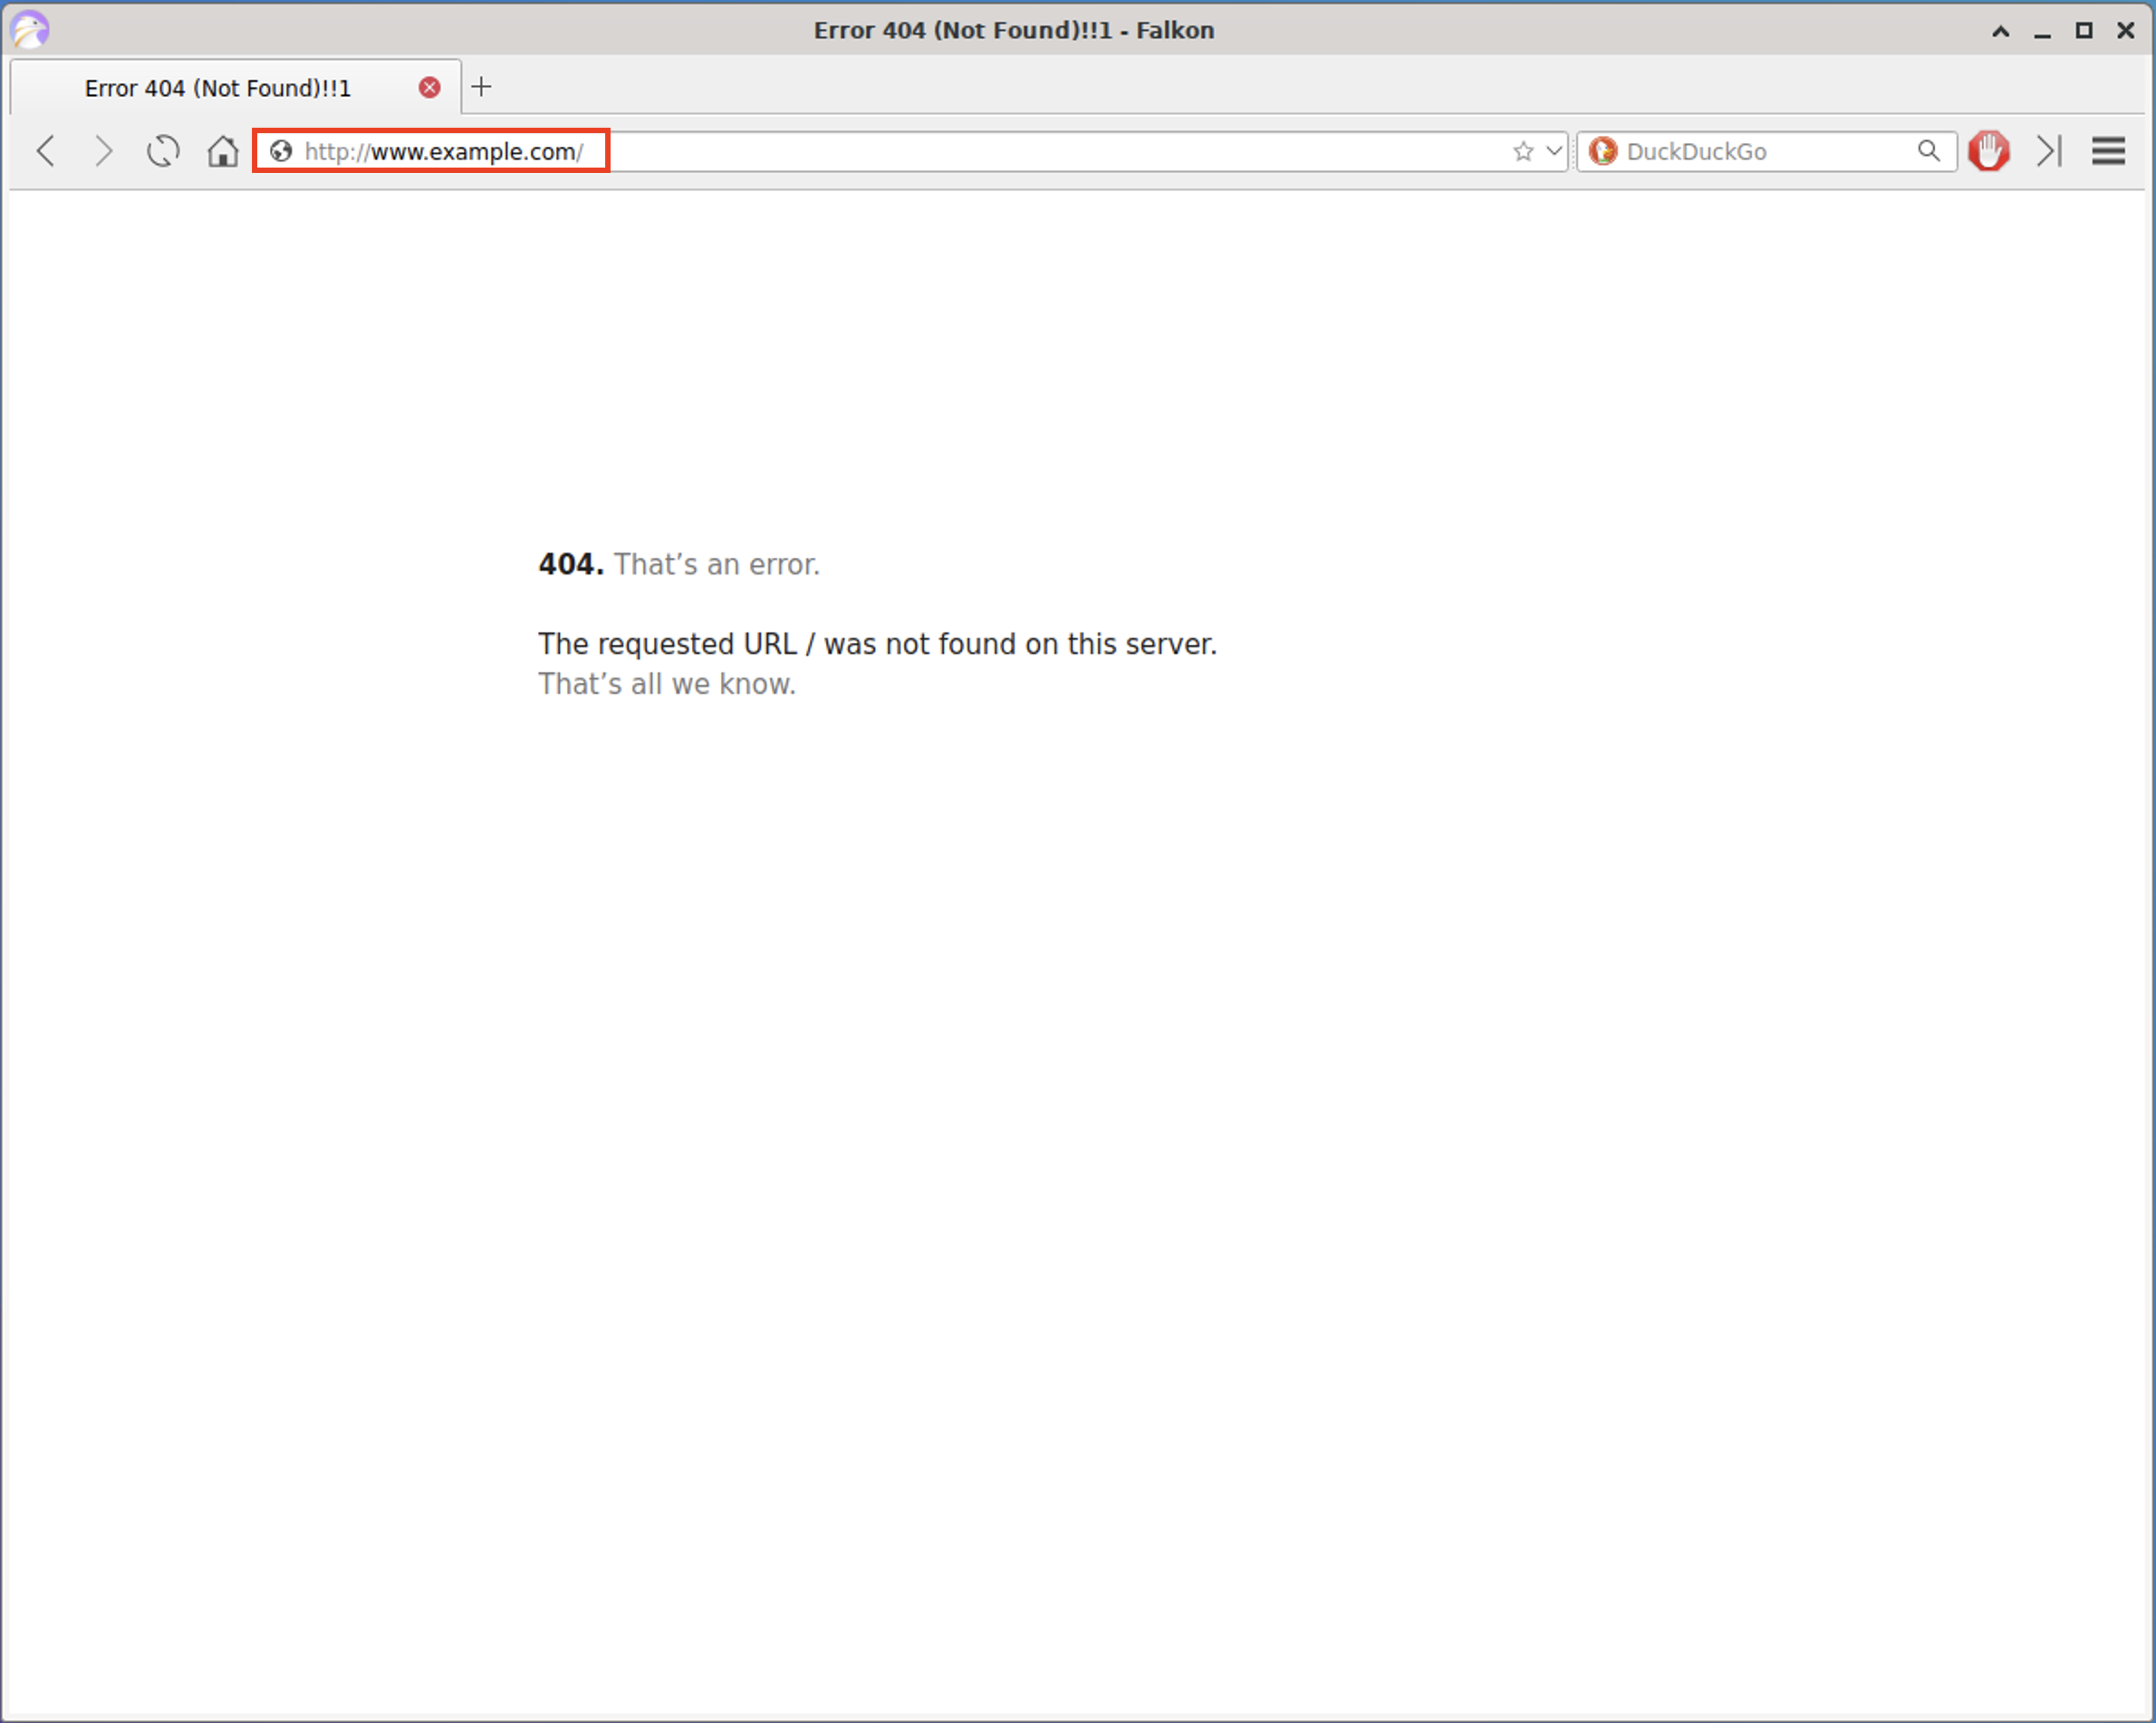

One thing to note is that we were not able to see the actual pages being spoofed in the browser. The reason we could only see the error messages show is because there are more advanced security features in the browser that will prevent us from showing the actual page, yet our pings and error messages have helped us verify that we were able to redirect the traffic based on our changes.

🎉 Congratulations, you've been able to modify the hosts file to take you to a different site! You've also been able to learn how domains are resolved on the system.